**UNIVERSITY OF MODENA AND REGGIO EMILIA**



**DEPARTMENT OF SCIENCE AND ENGINEERING METHODS THREE-YEAR DEGREE IN MANAGEMENT ENGINEERING**

**Development of a mathematical model**

**for the two-legged walking: application in the stability study**

**of pedestrian walkways**

**Rapporteur:** **graduating:**

**Prof. Fabrizio Pancaldi** **Martina Fornaciari**

**Co-rapporteur:**

**Prof. Claudio Giberti**

**________________________________________________________________________**

**2017/2018 Academic Year**

***To my family***

**Index**

|  |  |  |  |  |  |
| --- | --- | --- | --- | --- | --- |
| **1 Introduction and State of ........................................... ..................................................** | | | | | **........................................ 3** |
|  | **1.1** | **The pedestrian walkways ............................................... ..................................................** | | | **........................ 3** |
|  | **1.2** | **Problems related to the design of pedestrian walkways ...........................................** | | | **.3** |
| **2 Structure of the pedestrian walkways ............................................. ..................................................** | | | | | **................... 5** |
|  | **2.1** | **The resonance phenomenon .............................................. ..................................................** | | | **........................... 6** |
|  | **2.2** | **Massa and rigidity ............................................... ..................................................** | | | **........................................ 9** |
|  | **2.3** | **Damping ................................................. ..................................................** | | | **............................................ 10** |
| **3** | **The biped walking ............................................... ..................................................** | | | | **.......................................... 12** |
|  | **3.1** | **The vertical forces induced during ...........................................** | | **hike ....................................** | **14** |
| **4 strength models available in the literature ...........................................** | | | | **..................................................** | **......... 16** |
|  | **4.1** | **Models of strength in the time domain ...........................................** | | **..................................................** | **. 16** |
|  | ***4.1.1*** | ***Deterministic models ................................................ ..................................................*** | | | ***.......................... 16*** |
|  | **4.1.1.1 Models proposed for low-frequency floors ........................................** | | | | **.............................. 17** |
|  | **4.1.1.2 Models proposed for high frequency floors ........................................** | | | | **.............................. 22** |
|  | **4.1.1.3 Weaknesses of deterministic models ......................................... ....................................** | | | | **24** |
|  | ***4.1.2 Probabilistic Models ................................................ ..................................................*** | | | | ***.......................... 24*** |
|  | **4.1.2.1 The frequency step in probabilistic models ........................................** | | | | **................................. 28** |
|  | **4.2** | **Models of strength in the domain of frequency ...........................................** | | | **......................................... 31** |
| **5 Statistical model developed .............................................. ..................................................** | | | | | **............................ 34** |
|  | **5.1** | **............................................... of Markov Process ..................................................** | | | **.................................. 34** |
|  | **5.2** | **stride length and angle of the Report ..........................................** | | **step .................................** | **37** |
|  | ***5.2.1*** | ***Length of step ............................................... ..................................................*** | | | ***............................ 38*** |
|  | ***5.2.2*** | ***Angle step ............................................... ..................................................*** | | | ***.................................... 42*** |
|  | **5.3** | **Pitch Report strength and time ..........................................** | | **step ...........................................** | **47** |
|  | ***5.3.1*** | ***Pitch Time ............................................... ..................................................*** | | | ***.................................... 49*** |
|  | ***5.3.2*** | ***Force of ...............................................*** | ***step ..................................................*** | | ***...................................... 50*** |
|  | **5.4** | **time and stride length report ..........................................** | | **step .................................** | **54** |
| **6 Analysis of data .............................................. ..................................................** | | | | **..................................................** | **..... 56** |
|  | **6.1** | **utlizzata ................................................** | **Instrumentation ..................................................** | | **...................... 56** |
|  | **6.2** | **Software for data acquisition ............................................ ..................................................** | | | **................ 57** |
|  | **6.3** | **Critical factors in data collection .............................................** | | **..................................................** | **............. 59** |
|  | **6.4** | **Reworking ................................................** | **data ..................................................** | | **.................................. 60** |
| **7 Conclusions** | | **................................................ ..................................................** | | **..................................................** | **......... 66** |

**PAGE | 1**

**7.1****Future developments****66**

**8 Appendices****68**

**8.1****Appendix 1****68**

**8.2****Appendix 2****88**

**Bibliography****91**

**Acknowledgments****97**

**PAGE | 2**

**1 Introduction and State of the Art**

**1.1 THE CATWALK pedestrian**

**The pedestrian walkways are a type of infrastructure that took the last twenty years increasing importance in contemporary architecture. The growing urban expansion on the one hand and the push towards a greener mobility and so-called "green" on the other, have paved the way for numerous projects of pedestrian walkways to climb over the canals, rivers or roads. Despite the man's need, always, to overcome the obstacles of nature, there has been a considerable spread of walkways dedicated exclusively to pedestrians and cyclists only after the Second World War, following the development of the road network. The design of bridges of this type, requires the development of a sustainable approach aimed at encouraging the man's approach to the environment in which he lives, even in highly urbanized tissues. It also means promoting human use of bicycles as a means of transport not only for recreational use, but also for basic needs. Nowadays, the pedestrian walkways are now very widespread and built specifically for the purpose of crossing not only the obstacles of nature (such as rivers and gorges), but also the human settlement of costituta territory, in turn, road networks and highly branched and complex railway. In Figure 1, they are depicted two built pedestrian walkways, precisely, with the aim to overcome an obstacle: a road in a case, a river another [1].**

**1.2 ISSUES TO THE CATWALK DESIGN**

**pedestrian**

**Lightness and slenderness are intrinsic characteristics of these structures, natural consequences given**

**the narrowness of the expected loads (400-500 kg / m 2). Opera is the emblematic " *Millenium Bridge* "London, where" lightness "was the key word behind the design. Following the opening in 2000, the bridge was crossed by thousands of pedestrians and only two days after it was closed because of the resonance**

**and vibration effects that were not adequately considered and analyzed during the design phase. An important aspect of pedestrian walkways, not found in other infrastructure (such as roads or bridges crossing used by vehicles), is in fact to ensure the " *Human comfort* ". The convenience by pedestrians is closely linked to the possible deformation and vibration of the structure itself. The vibrational phenomena, as a rule, do not constitute the cause of a lowering of structural safety, to the exclusion of particular cases of resonance such as the one mentioned above. However, it is clear that sharp fluctuations in the person ARISING FROM, passing on these walkways, feelings of discomfort and fear. In the walkways it is therefore of vital importance to monitor and evaluate the mode of vibration of the same in order to avoid discomfort situations that could lead to the escape. On reflection, induced vibration on**

**PAGE | 3**

**structure, should remain within a range of human tolerance, ie frequencies adequately distant from the low frequencies annoying perceived by pedestrians. Several references are planning to establish a natural frequency threshold. Among these, for example, they emerge NTC 2008, where it is indicated that, for structures with rhythmic passage as the walkways, a higher natural frequency to 5Hz ensures a good level of comfort for the user. Despite the present valid references, evaluation of vibrations induced by man is still widely debated, given the algorithms and how they define input (dynamic load) [1].**

**The purpose of this thesis is to provide a statistical mathematical model that can be implemented in the study of stability of pedestrian walkways. In the first analysis we will address the issue relating to the structure of the pedestrian walkways. Then, we look at the man walking process, specifying the relevant parameters and key concepts. Then, we will present some mathematical models available in the literature in reference to the human walk. Finally, it will be introduced the related statistical model developed from the experimental measurements made on a floor strength.**

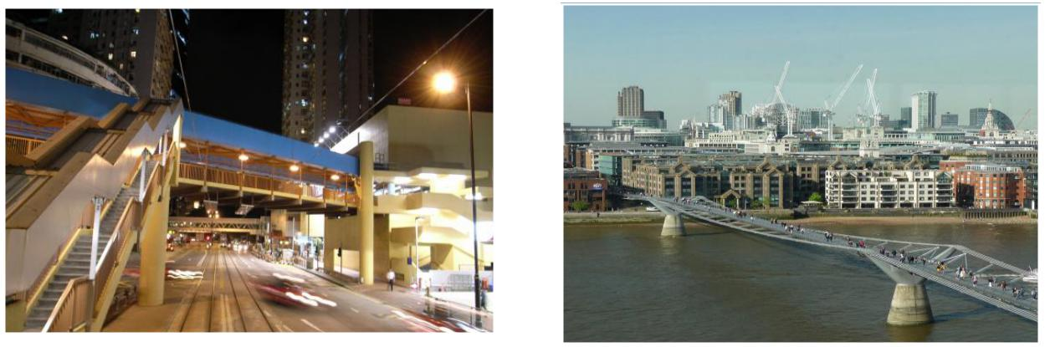

**(to)** **(B)**

**Figure 1_ (a) pedestrian walkway in Hong Kong (b) Millenium Bridge in London**

**PAGE | 4**

**2 Structure of the pedestrian walkways**

**Any analysis concerning vibrations should be broken down into its three key components, as shown in**

**Figure 2:**



|  |  |  |  |
| --- | --- | --- | --- |
| **INPUT** | **SYSTEM** | **OUTPUT (the** |  |
| **(structural floor)** |  |
| **(excitation** | **receiver** |  |
|  |  |
| **source)** |  | **response)** |  |



***Figure 2_ components related vibration analysis***

**Human activities like walking, running and jumping are common sources of excitations induced dynamics and thus constitute the above analysis input. The excitation-induced remains still little known; This is due to several uncertainties associated to walk. These uncertainties make it difficult to predict the same commit the dynamic load produced.**

**As regards the system, namely the structure of the walkway, it represents the medium that transmits the vibrations from the source to the receiver. A typical receiver of vibration of the walkway is the pedestrian who often also represents the source of vibrations, due to the dynamic load which induces on it.**

**Therefore, it is very important to know the dynamics of mass, stiffness and damping properties of a walkway in order to thus determine its dynamic response according to the following equation relative to the motion of a system with several degrees of freedom (MDOF, namely " *multi-degree of freedom ") [* 2]:**

**••̈ (•) + ••̇ (•) + •• (•) = • (•)**

**In which the coefficients M, C and K represent the mass matrix, respectively, the damping matrix and the walkway of the stiffness matrix, each order**

**••• ( with n equal to the number of degrees of freedom DOF). Instead, • (•), •̇ (•)is •̈ (•)**

**representing the vectors, as a function of time, displacement, velocity and acceleration respectively. Finally • (•) It is the external force. The mass and stiffness matrices, which depend on the geometry of the walkway and the properties of the material of which the walkway itself is made, are usually determined by the concept of a finite element (FE). According to this concept, a real structure with an infinite number of degrees of freedom must be discretized into a set of FE which has a finite number of DOF, represented by the components of the vector x. For each type of element which together constitute the identified can therefore be defined as the mass and stiffness matrices and, at a later time, thanks to their combination, you can determine the mass and stiffness matrices for the entire structure. As regards the definition of the damping matrix, however, we must resort to ratios of modal damping,**

**PAGE | 5**

**Making the assumption that the system is linear and proportionally damped, which is a good prerequisite for most of the walkways, the data system • equations can be separated in • equations, each of which has only one variable, namely in • systems each single degree of freedom whose standard form [2] is:**

**•̈• ( •) + 2ζ • ω • •̇ • ( •) + ω •2 • • ( •) = • • ( •)• •**

**In this equation we have:**

**• •̈ •̇ •) is • •) are, respectively, the acceleration, the speed and the modal displacement;**

**•,** **• (** **• (**

* **ζ • is the damping ratio;**
* **ω • It is the natural frequency of the nth vibration mode;**
* **• • ( •) It defines the strength of the nth vibration mode;**
* **• • It is the modal mass. As a result, the total displacement • (•) It can be obtained by a linear**

**combination of modal vectors Φ • whose coefficients are the displacements • • ( •)**

**with • = 1, ..., •.**

**• (•) = Φ 1 • 1 ( •) + Φ 2 • 2( •) + ⋯ + Φ • • • ( •)**

**In general, it often happens in the walkways of domains that a vibration mode on the other, and therefore, to calculate the structural dynamic response, you can use a single modal equation single degree of freedom.**

**2.1 THE PHENOMENON OF KENT**

**Given the importance of the study of pedestrian walkways stability, it is appropriate to introduce the concept of resonance of nonlinear oscillators with periodic forcing. When an oscillating system is set in motion, it oscillates at its natural frequency • 0. However, if the system is acting an external force with its own particular frequency, it has so-called forced oscillation [3]. Suppose, therefore, to have a one-dimensional damped harmonic oscillator, namely a fixed object at the end of a homogeneous spring, spiral and of negligible mass, to which an external force is applied, along the axis of the spring (Figure 3).**

**It is considered in fact a one-dimensional damped system as in real life situations the oscillating systems are subject to dissipative phenomena, which therefore dampen the amplitude of the oscillations by dissipating energy due to the presence of friction forces. These forces, in turn, can be caused by:**

* **sliding friction (due to the sliding of two surfaces relative to one another, as in the case of a mass-spring system in which the mass** [**moves on a**](http://fisicaondemusica.unimore.it/Moto_armonico.html) **"rough" surface), which in turn can be static or dynamic;**
* **friction between internal parts of the oscillating system;**

**PAGE | 6**

* **friction due to the resistance of the medium (for example, a fluid such as in the case of a pendulum that oscillates in air). Such friction can be considered, as a first approximation, directly proportional to the speed. It can therefore be described by the following expression: • • = -••, with *b* coefficient of viscous friction.**

**We can then express the external force such as: • ••• = • cos (ω•) in which *k* It represents the spring constant and elastic *m* It indicates the mass of the object attached to the spring. Finally, to Hooke's law, the oscillator is subject to the elastic restoring force**

**• • = -•• with *x* equal to the displacement carried out.**

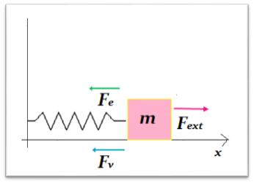

***Figure 3_ Representation of a forced harmonic oscillator***

**The equation of motion forced oscillatory, for the Newton's second law ( •⃗ = ••⃗) and so:**

|  |  |  |  |  |  |  |  |
| --- | --- | --- | --- | --- | --- | --- | --- |
| **• 2 • •• 2 + •** | | | | **••** | | |  |
|  |  |  |  |  |  |  |  |
|  | **•** | | | **•• + ω 02 • = • • cos (ω•)** | | |  |
|  |  |
|  |  |  |  |  |  |  |  |

**where is it ω 02 = • 2 •.**

**It shows that every solution of the above equation can be written as follows:**

**• (•) = • * ( •) + • 0 sin (Φ + ω• 0)**

**where is it**

**• 0 = •**

**1**

**•** **√ (ω 02 - ω 2) 2 + ( •ω**

**•) 2**

**PAGE | 7**

**is**

|  |  |
| --- | --- |
| **Φ 0 = arctan ((ω 02 - ω 2) •** | **)** |
| **•ω** |  |

**is • * ( •) is a function that tends to zero if • It tends to infinity. As a result you will have it for • sufficiently large,**

**• (•) ≅ • 0 sin (Φ + ω• 0)**

**and therefore the motion is approximately harmonic with a frequency equal to that of the driving force and amplitude**

* **0.**

**In forced oscillation, the oscillation amplitude, and therefore, the energy transferred to the oscillating system, therefore depends on the ratio between • 0 is •, where is it •**

**It represents the frequency imposed by the external force acting on the system. In fact, considering the amplitude • 0 of the oscillation as a function of the frequency of the forcing ω, it is seen that the maximum value of • 0 ( ω) It is reached**

|  |  |  |  |  |  |  |  |  |  |  |  |  |
| --- | --- | --- | --- | --- | --- | --- | --- | --- | --- | --- | --- | --- |
|  |  |  |  |  |  |  |  |  |  |  | **2** |  |
| **ω = √ω 02 -** | | | | | **1** | **2( ••)** | | | | |  |  |
|  |  |  |
| **and the maximum amplitude will be:** | |  |  |  |  |  |  |  |  |  |  |  |
| **• 0 ( ω) =** | **•** |  | **1** | | | | | | | |  |  |
| **• ∙** |  |  |  |  |  |  |  |  |  |  |
|  |  |  |  |  |  |  |  |  |  |
|  | **•** | | | | | | | **2** |  |
|  |  |  |
|  |  |  |  | **2 •)** |  |
|  |  |  |  |  | | | | | |  |  |
|  |  |  | **• ∙ √ω 02 - ( •** | | | | | | | |  |
|  |  |  |  |  |  |  |  |  |  |  |  |  |

**previous expression it is seen that the amplitude can reach extremely high also peaks for ω near ω 0 when the coefficient *b* of viscous friction it turns out to be very small, ie in the presence of low damping and hence less dissipation of energy. In addition, the oscillator response curve becomes more "narrow" the lower the coefficient of friction: this means that the system is much more selective at least dissipates energy outside. As illustrated in Figure 4, which shows • 0 ( ω) for different values ​​of viscosity, in fact, identifies a very strong damping for the green curve that does not reach a particularly significant peak while the black curve, very narrow, subject to a particularly lightweight damping, touches a value of very high amplitude. This phenomenon is known as resonance and the natural oscillation frequency ω 0 the system is called the resonant frequency.**

**PAGE | 8**

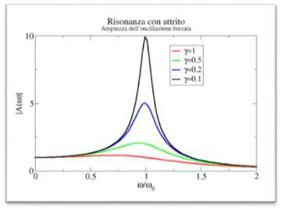

***Figure 4_ oscillation amplitude as a function of the angular velocity (image courtesy of***

[***http://fisicaondemusica.unimore.it )***](http://fisicaondemusica.unimore.it/)

**2.2 MASS AND STIFFNESS**

**Knowing the properties of materials and the geometry of the gangway makes it possible to develop a FE model and to thus determine the natural frequencies of the walkway itself. Because of ambiguity in the FE of the modeling process, the results obtained can however also be affected by considerable errors. Often, as it was found by Deger et al. [4], these uncertainties are caused by the "boundary conditions" of the walkway. If there are data both analytical and experimental (and assuming the reliable experimental data and of good quality) you can proceed to a comparison between the same in order to update the FE model. The most critical factors in the updating of the catwalks are the properties of the materials used, the boundary conditions and, finally, modeling of some structural and non-structural elements such as handrails and cables. These elements can affect the dynamic behavior of the footbridge and thus significantly should be treated with care. In addition, even significant changes in temperature can affect the dynamic properties of the catwalk. By way of example, Ventura et al. [5] have found that the increase in temperature from 21.4 ° C to 42,11 ° C was accompanied by a decrease of the fundamental frequency of a 7.1% pedestrian walkway. also significant changes in temperature can affect the dynamic properties of the catwalk. By way of example, Ventura et al. [5] have found that the increase in temperature from 21.4 ° C to 42,11 ° C was accompanied by a decrease of the fundamental frequency of a 7.1% pedestrian walkway. also significant changes in temperature can affect the dynamic properties of the catwalk. By way of example, Ventura et al. [5] have found that the increase in temperature from 21.4 ° C to 42,11 ° C was accompanied by a decrease of the fundamental frequency of a 7.1% pedestrian walkway.**

**The general procedures to be able to make a FE model updating, refer to textbook Friswell and Mottershead [6]. In general, the FE model update can be done manually, by trial and error, or automatically through the software developed for this purpose. Typically, it is recommended as a first thing, to carry out a manual update, such as to allow the creation of an FE model that present significant departure parameters (in this regard is**

**PAGE | 9**

**useful to conduct a sensitivity analysis) to apply then, at a later time, the automatic procedure [7, 8]. The most uncertain parameters, including the rigidity of some non-structural elements, the dynamic modulus of elasticity for the concrete, the stiffness of the cracked concrete and the stiffness of the media, should be investigated in order to obtain a correspondence with the experimental data. To verify this correspondence is usually uses the criterion of modal reliability (MAC) or the coordinated modal security policy (COMAC) representing the degree of correlation between the methods of analytical and experimental vibration (of COMAC AND MAC values ​​should be between 0 and 1) [6, 9]. If the axial forces of the structure (and therefore the effects of the second order) are relevant, the geometric stiffness should be taken into consideration together with the elastic stiffness, which may therefore influence the mode of vibration of the structure itself [10]. Large axial forces are typical in cable-stayed bridges, in reference to cables, towers and beams. Around the 90s, a survey was conducted on a guyed walkway taking into account the geometric stiffness for the cables, whose behavior was very difficult to model due to the sensitivity of the results in relation to the cable modulus of elasticity [11 , 12]. Subsequently Khalifa et al. [13] have found that, in the case of cable-stayed bridge, shaping the wooden footbridge as a plate-like element leads to a better agreement between the modal properties obtained experimentally and analytically. In addition Pimentel [14] found that the handrail in a tape walkway with ribs increase the fundamental frequency of approximately 20%, as then reiterated by Obata et al. [15]. Therefore, in conclusion, the handrails of pedestrian walkways can increase, so too substantial, the frequencies of the vertical vibration modes.**

**2.3 DAMPING**

**Each structure has inherently the ability to dissipate energy: damping precisely represents the energy dissipation in a vibrating structure [16]. This feature is very useful because it allows the reduction of the structural response to dynamic excitation close to resonance. So, being the condition of almost fundamental resonance in considering the suitability of the walkway to the vibrations induced by man, it is very important to model the damping very accurately. The dissipation mechanisms are divided into two categories: the mechanisms of "dissipation" thin out that the energy within the confines of the structure and mechanisms of "dispersion" (or "radiation") that propagate the energy away from the structure. It defines "effective damping" the overall damping of the structure which includes both the above mechanisms and it is precisely this damping is measured [17]. Mold mathematically these damping mechanisms is quite complex. Among various damping models developed, the most widely used because of its simplicity, it is viscous. The latter is usually expressed in its modal shape, then using the**

**PAGE | 10**

**damping ratios ζ • defined for each vibration mode separately. This proves to be very useful in the case of pedestrian walkways, for both the modeling of FE for both the collection and analysis of the experimental measurements. As mentioned previously, shaping the damping is very important if the structure to vibrate at a resonant frequency, ie, when the stiffness and inertial forces tend to cancel each other. For this purpose, therefore it becomes necessary to conduct the tests so that the modeling is more accurate. In tests it is very important to choose the frequency content to the strength of excitement that will generate the resonance phenomenon for the vibration mode investigated [16].**

**The current manufacturing technology, aimed at creating more and more slender and aesthetic structures, have led to a reduction in damping structures themselves due to a significant reduction in friction compared to the old structures. In support of this, Wyatt [18] states that until 1960 the ratio of viscous damping in the bridges could not be less than 0.8%. In the mid 40s the minimum value was**

**1.6%, while today's modern bridges and pedestrian walkways steel exhibit usually one of 0.5% damping.**

**PAGE | 11**

**3 The bipedal walking**

**Walking is in our eyes, a simple and automatic act that could be defined as *"The harmonic movement* *that the human being does to move from one place to another."* If we carefully focus on the dynamics ofhuman movement we find that it is a complex mechanism. It is therefore important, in the first analysis, to understand what constitutes a complete walk cycle. The latter consists in the human body movement in the time interval from the beginning of a step with one foot up to the beginning of the next step with the same foot, as shown in Figure 5.**

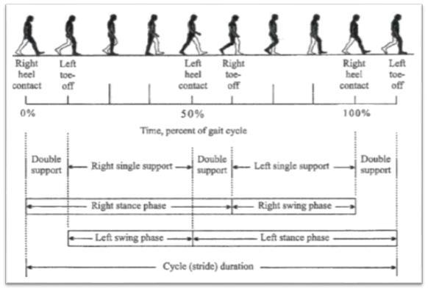

***Figure 5_ A single complete walk cycle (image courtesy of Racic et al.)***

**Before starting to walk the feet are in contact with the ground and the body is in balance thanks to the double support ( " *double support* "In Figure 5). We can then distinguish a series of consecutive events as follows [19, 20, 21]:**

1. **The left foot off the ground ( " *left toe-off "* in Fig. 5) in the direction of walking, or gives the impetus to begin the movement for advancement, and at the same time the right foot provides a single support body ( " *right single support* "In Fig.5) and therefore the balance is borne by the leg still in contact with the ground. Therefore, as will be specified**

**PAGE | 12**

**subsequently, the left foot is in a swing phase while the right foot is in a contact phase.**

**2. Subsequently, the left foot back into contact with the ground ( " *left heel***

***contact "* in Fig. 5) and the body again passes through a phase of dual standby.**

**3. As a result, we have a sort of "exchange phase" in the sense that the right foot**

**begins a phase of oscillation ( " *right toe-off "* in Fig. 5), while the left foot is still in a phase of contact and provides the single left support ( " *left single support* "In Figure 5).**

1. **Then, right foot back in contact with the floor ( " *right heel contact "* in Fig. 5) and the body goes through a double support phase.**
2. **Finally, the left foot returns to rise from the ground to begin a new phase**

**of oscillation ( " *left toe-off* " in Fig. 5) and the cycle is complete. So during the walk with each step the foot passes through two phases: the phase of oscillation ( " *swing phase* ") And the contact phase (" *stance* *phase* "). The first refers to the period in which the foot is lifted from the ground, while the second relates tothe period during which the foot touches the floor. In particular, this last phase, begins when the heel hits the ground and ends with the complete support of the foot on the ground [22].**

**Simultaneously with this, the body goes through two phases during the walking process, ie the phase of dual support and the single support phase. The double support phase occurs when both feet are in contact with the floor and does not constitute more than 20% of the walking cycle. In relation to the latter assertion, it was verified that with increasing vehicle speed, this step comprises a smaller percentage of the travel time. On the contrary, the body is in the phase of single support when one foot is in contact while the other is raised from the ground [23, 24].**

**The parameters used to describe human gait are divided into time and space [25]. In particular, we are interested in time parameters are:**

* **walking speed: intensity of the horizontal speed in the gait direction;**
* **Cycle Time: time that elapses between two successive supports of the same foot to the floor [21];**
* **Step Frequency: number of steps in a time interval. Alongside these, we find**

**the following parameters of space:**

* **Stride length: distance measured between the heels during a single step in the direction of the walk;**
* **Stride width: distance measured transversely between the two lines (respectively passing through the midpoints of the right and left heel),**

**PAGE | 13**

**imaginary, that describe the trajectory followed by each foot respectively;**

* **Length of the walk cycle: distance measured between two consecutive contacts of the same foot along the direction of the walk. It also represents the total distance traveled during a cycle period of [20].**

**3.1 VERTICAL FORCES INDUCED DURING THE WALK**

**In regard to the various parameters that characterize the man walking process, we can identify the presence of two types of randomness in walking: the variability in inter-and intra-subject variability [26]. The inter-variability exists with regard to the fact that different people will have different key parameters related to induced forces, the walking speed, etc. The intra-subject variability, however, exists because an individual never repeats two steps identical in sequence. Basically, you can say that a person produces different forces at every step.**

**The dynamic forces produced by humans during the walking process typically have components in the vertical directions, horizontal and parallel-orizzontaletrasversale respect to the direction of movement. However, by virtue of its intensity and the importance that has in the study of stability of floors and walkways, the only vertical force component will be addressed in this thesis.**

**Following studies conducted by different researchers, including Harper, Blanchard et al., Ohlsson and Kerr [27, 28, 29, 30] it has come to the conclusion that the vertical force has typically two peaks and a depression.**

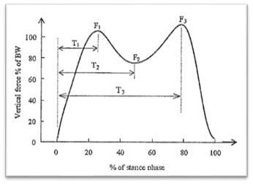

***Figure 6_ trend of the vertical force during a single step (image courtesy of Racic et***

***to the.)***

**PAGE | 14**

**As shown in Figure 6, the force is expressed as a percentage of the individual's body weight in examination while the time is normalized with respect to the contacting step. When the heel strikes the floor, the dynamic force increases until it reaches a peak value equal to F 1 at time T 1 which corresponds to approximately 25/30% of the duration of the stance phase (or contact). After the force has a drop, ending at time T 2 with value of the force equal to F 2. AT 2 the heel is that the tip of the foot are in contact with the ground, while the opposite foot is in the swing phase. Subsequently, the heel rises and the vertical force increases until it reaches a second peak, F 3 at time T 3 in the vicinity of the stance phase of the opposite foot. Finally, the salt foot off the floor and the force decreases rapidly to zero at the completion of the stance phase.**

**It was noted, however, that this graph changes considerably at different walking speed. It is believed that two main factors affecting amplitude of the peak force: the weight of the person and the frequency steps. The increase of these factors leads to higher peak forces.**

**Wheeler [31, 32] has classified different types of human movements, organized by the slow walking to running (Figure 7). Each of these categories had a unique single-step dynamic peak amplitude strength, shape and period of contact. In addition, the author said that different parameters like stride length, walking speed, the contact time, the peak force and step frequency are related. For example, the frequency increase step leads to shorten the contact time and increase the peak force.**

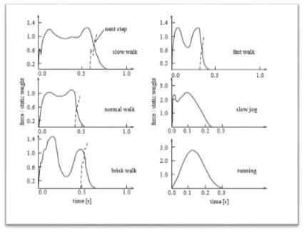

***Figure 7_ trend of the vertical force in different movement activities (image courtesy of Živanović et al.)***

**PAGE | 15**

**4 strong models available in the literature**

**According to the said in the previous section, it is necessary to develop reliable mathematical representations of the vertical dynamic forces produced during the walk. The resulting models can then be implemented to foresee, at the design stage, the vibrations of walkways, decks or floors. The modeling of the forces (where forces means the vertical ones) induced by humans is complex for a number of reasons. First, the dynamic force generated by a single pedestrian is a narrowband process that, being little known, it is difficult to represent. In addition, there are many different types of induced forces which change both in time and in space in relation to many parameters characterized by high variability in inter- and intra-subjective. Finally the influence of the number of people and their degree of synchronization are difficult to generalize because the modeling of the dynamic force induced from the crowd is not yet clearly defined, despite some attempts to address this problem. Despite these difficulties, many researchers have proposed different models, some used in the design guides, based on more or less justifiable assumption. In the literature there are two types of models: the strong patterns in the time domain and the strong patterns in the frequency domain [33].**

**4.1 FORCE MODELS IN TIME DOMAIN**

**These models can be divided into two categories: strengths models in the time domain deterministic or probabilistic. The deterministic models aim to create a unique model of strength applicable to every individual without considering the natural variability directly between people. These models also do not take into account intra-subject variability, that are based on the assumption that both the individual's feet produce exactly the same force and that this force be periodic. Otherwise, the probabilistic models value the fact that each individual has a unique set of parameters (inter-variability) which directly influences the forces produced as the person's weight, the frequency of steps and so on. Each parameter, therefore,**

**4.1.1 deterministic models**

**The magnitude of the force induced by man has been considered to depend significantly on the ratio between the frequency of the pedestrian walking and the natural frequency of the floor. In literature there are presented two types of floorings according to their natural frequency: low-frequency and high-frequency floors floors. Many studies confirm that the dynamic response in the two cases may be significantly different. Typically, the threshold value that distinguishes the two types of floors is 9-10Hz with floors that have at least one natural frequency**

**PAGE | 16**

**less than 9-10 Hz are low frequency, while the minimum natural frequency of the high frequency flooring is above this value. Several studies have shown that in the low-frequency floors, may occur the (quasi-) resonance phenomenon if the natural frequency of the floor is close to the typical rhythm human gait or an integer multiple of the frequency of walking while this does not happen in HF floors. Currently there is a deterministic model that can be used for floors at both low and high frequency. Therefore, researchers have developed several models of strength for each [34].**

***4.1.1.1 Models proposed for low-frequency floors***

**It is known that each periodic force Fp (t) with a period T can be represented by a Fourier series. To which, being considered, by hypothesis, the periodic vertical dynamic force induced by a pedestrian, can be expressed in the time domain by a sum of harmonic components [35]:**

**•**

* **• ( •) = + • Σ•α • sin (2π•• • • - Φ •) ,**
  + **= 1**

**where is it:**

* ***G* is the weight of the person (unit of measurement [N]);**
* ***the* is the order number of the accordion;**
* ***α the* It is the Fourier coefficient of the accordion *the-* th, also known as dynamic load factor (DLF);**
* **• • is the frequency of the steps (unit of measurement in [Hz];**
* **Φ • the harmonic phase *the-* th (unit of measurement in [rad]);**
* ***n* the total number of taxpayers harmonics.**

**On the basis of the Fourier decomposition, many researchers have attempted to quantify the DLF. The dynamic load capacities are the basis for this most common model of perfectly periodic force. Therefore, to obtain correct values ​​of these factors means to generate an accurate force deterministic model. Blanchard et al. [28], for example, proposed a deterministic force model such that, if the vertical fundamental frequency of the walkway did not exceed 4 Hz, the resonance occurred due to the first harmonic of the force induced by the pedestrian with DLF equal to 0.257 and weight of the person equal to 700N. Instead, for fundamental frequencies between 4 to 5 Hz, the resonance occurred due to the second harmonic of the same strength and therefore, applied some reduction factors,**

**Later in 1982, Kajikawa, according Yoneda [36], developed an improved model compared to the previous Blanchard. In fact, he formulated in his**

**PAGE | 17**

**model the "correction coefficients" (ie DLF) as a function of step frequency. In addition, it included in the model also walking speed (unit of measurement [m / s]) as *output* the step frequency, as shown in Figure 8.**

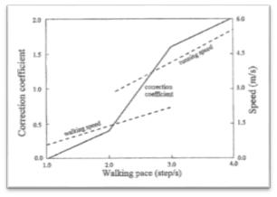

***Figure 8_ walking speed and DLF as a function of step frequency (image courtesy of Živanović et al.)***

**Subsequently, Bachmann and Ammann [37] have reported the first five harmonics for the vertical component of the induced force from the pedestrian and even harmonics for the lateral and longitudinal direction of the same strength (figure 9). They reported that the first and the third harmonic of the side and the first and second harmonic of the longitudinal force are dominant. The authors have also suggested DLF for the first harmonic of the vertical force of 0.4 and 0.5 at frequencies of, respectively, 2.0 and 2.4HZ, with linear interpolation for intermediate frequencies. As regards the second and third harmonic, have proposed a DLF value of 0.1 if the pitch frequency is close to 2.0 Hz.**

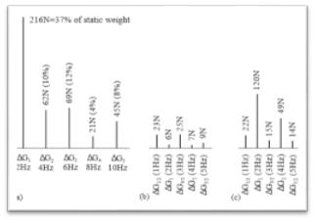

***Figure 9_ Components harmonics of the force-induced in direction (a) vertical, lateral (b) and***

***(C) the longitudinal axis (image courtesy of Živanović et al.)***

**PAGE | 18**

**In the late '80s, Rainer [38] and his colleagues have made a significant contribution by measuring, using an instrumented platform, the continued strength induced by various activities carried out by man: walk, run and jump. Through their studies, they confirmed that the DLF strongly depended on the frequency of the task. Also, they included in the force models they propose, the values ​​of the DLF of the first four harmonics of considered force. The only deficiency of this research was that it lacked statistical reliability because the measurements were made using a few subjects.**

**A very thorough work on the force induced by man while walking, it was done by Kerr [30] during his PhD. He recruited 40 test subjects through which he obtained about 1000 force measurement for single pass covering step frequencies from 1Hz (unnaturally low) to 3 Hz (just as unnaturally high). Each step was repeatedly added and added to synthesize a waveform that represents a walk in a certain period of time to be able to estimate the values ​​of DLF. With the exception of the first harmonica when he noticed that the dynamic forces induced by the pedestrian increased with increasing step frequency, Kerr reported a large spread in the values ​​of these factors. Therefore, for harmonics higher than the first, the DLF values ​​were characterized statistically provided it mean values ​​and standard deviation (as can be seen from Figure 10). This study was partly criticized by Racic et al. [34], due to the inability by Kerr to represent, using data collected by him, the intra-subject variability, namely that a single individual is unlikely that performs two steps identical in sequence.**

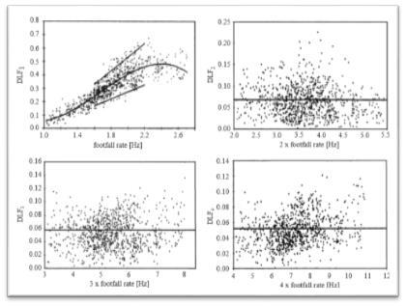

***Figure 10_ DLF of the force induced by a pedestrian while walking for the first four harmonics (in***

***Following the studies conducted by Kerr) (image courtesy of Živanović et al.)***

**PAGE | 19**

**Following this study, Young and Willford [39, 40], have outlined the basic principles, used by *Arup* *Consulting Engineers,* to develop a reliable guide for the modeling of the induced force and thecorresponding structural responses. Young and Willford have applied a statistical regression on the data published by different researchers (Figure 11). On reflection, they then proposed the DLF for the first four harmonics as a function of pitch frequencies between 1 and 2,8Hz (suitable values ​​in the planning area):**

|  |  |
| --- | --- |
| **α 1 = 00:41 (• - 0.95) ≤ 0:56;** | **1•• ≤ • ≤ 2.8••** |
| **α 2 = 0.069 +0.0056 •;** | **2•• ≤ • ≤ 5.6••** |
| **α 3 = 0.033 +0.0064 •;** | **3•• ≤ • ≤ 8.4••** |
| **α 4 = 0.013 +0.0065 •;** | **4•• ≤ • ≤ 11.2••** |

**where is it *f* represents the relevant harmonic frequency (equal to an integer multiple of the pitch frequency). Young stated that these project recommended values ​​were 25% exceeding probability. This has made him one of the first researchers took into account the stochastic nature of human walking.**

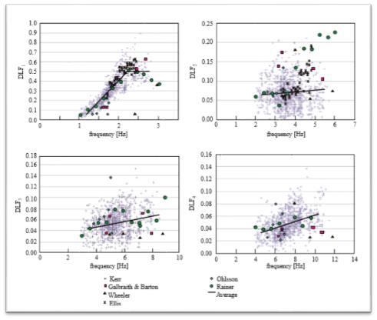

***Figure 11_ DLF of the force induced by the pedestrian for the first four harmonics (hereinafter to studies conducted by different researchers reworked by Young) (image courtesy of Živanović et al.)***

**PAGE | 20**

**In the table of Figure 12 they are presented DLF proposed by several authors in relation to the vertical force induced by a single pedestrian. It should be emphasized that the studies cited above, the DLF were obtained through experimental measurements of the force-induced while walking on a hard surface. Therefore, the models may not be accurate in the design of flexible floors. Baumann and Bachmann [41], for example, have reported a magnitude difference of ambulation load on hard floors of 10% more than that measured on flexible pavements. Later in 1997, Pimentel [42] found that DLF for the first and second harmonic, in the case of flexible walkways, They were considerably lower than those reported in the literature in reference to hard floors. Bocian et al. [43] it then a pendulum model of strength reversed inspired from biomechanics to represent pedonepasserella dynamic interaction. Aforesaid model it has been found particularly useful in the case of crowds in motion.**

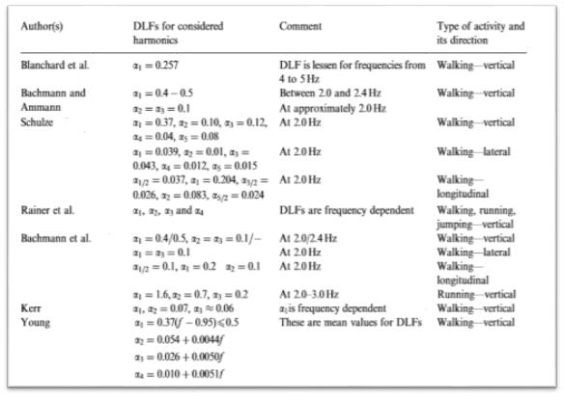

***Figure 12_ Table with DLF of the force induced by a pedestrian while walking proposed by several authors (image courtesy of Živanović et al.)***

**PAGE | 21**

***4.1.1.2 Models proposed for high frequency floors***

**In general, the literature on modeling of the induced force of high frequency floors is rather limited due to the fact that the human discomfort against vibrations are mainly found in low frequency floors. As already mentioned, they define high frequency floors those with a minimum natural frequency greater than 9-10Hz. A difference of the resonant behavior which present the low-frequency floors, the response to excitation induced dynamic man of high frequency floors shows a transitional profile (or impulsive) [44]. From Figure 13 shown at the bottom it is noted that, unlike the typical low frequency resonant response of flooring which involves an accumulation of the vibration response of the structure to each next step, vibration feedback of subsequent steps do not accumulate in the case of high-frequency floors due to the decay of the structural damping. In fact, a first touch of the heel on the floor causes an initial peak response which is followed by an oscillation of the floor itself at its natural frequency with an associated rate of decay to the damping ratio of the fundamental mode. At the next step, a new impulse response is generated that, therefore, not going to add with the previous one. a first touch of the heel on the floor causes an initial peak response which is followed by an oscillation of the floor itself at its natural frequency with an associated rate of decay to the damping ratio of the fundamental mode. At the next step, a new impulse response is generated that, therefore, not going to add with the previous one. a first touch of the heel on the floor causes an initial peak response which is followed by an oscillation of the floor itself at its natural frequency with an associated rate of decay to the damping ratio of the fundamental mode. At the next step, a new impulse response is generated that, therefore, not going to add with the previous one.**

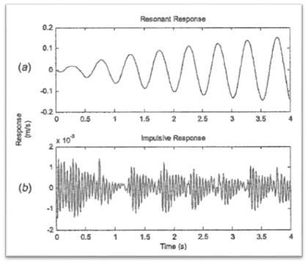

***Figure 13_ comparison of the response behavior excitement dynamic and continuous man in low frequency floors (a) and high frequency (b) (image courtesy of Middleton and***

***Brownjohn)***

**PAGE | 22**

**One of the most important studies in this area was conducted by Willford et al. [45], whose model has been developed on the basis of similarity found between the impulse response of the high frequency floors under dynamic excitation-induced and the systems response to a single degree of freedom under a series of impulsive forces. Willford et al. They simulated the responses of a large number of single degree of freedom systems (SDOF ie " *single-degree of freedom* ") With unity modal mass and different natural frequencies, under the continuous and dynamic forces induced by man while walking from measurements previously synthesized single-step performed by Kerr. For each simulated response, said authors then calculated the peak velocity of the SDOF system which, having its unity modal mass system, was equal to a quantity called effective pulse. From this study it found that the effective pulse increases in inverse proportion reason is the step frequency is the natural frequency of the floor. Therefore, based on the analysis of statistical data shown in Figure 14, the effective pulse • ••• is calculated with a probability of exceedance of 25%, as follows:**

* **••• = 54 • 1:43• •1.30**

**where is it *f* It is the walking frequency (measured in [Hz]) and *f* *n* It is the natural frequency of the floor (also measured in [Hz]).**

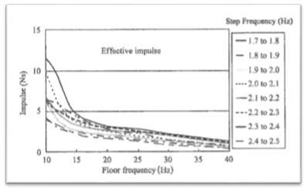

***Figure 14_ effective pulse in step frequency function and frequency of the floor (floor to high frequency) (image courtesy of Racic et al.)***

**PAGE | 23**

***4.1.1.3 Weaknesses of deterministic models***

**In general, deterministic models have different gaps that have been identified over the years by engineers and scientists. First, they do not evaluate explicitly the variability intra- and inter-subjective typical human walking. Secondly, the choice of the most appropriate model depending on the type of floor (whether high or low frequency) has been shown to not be effective in the presence, for example, a floor with a natural frequency of 9-10Hz. Finally, the vibratory response of a surface under the dynamic excitation induced by man is calculated, using the deterministic models, as a number which in turn will then be compared with a tolerance limit. This involves a binary evaluation " *acceptable / unacceptable* "It therefore does not provide sufficient information to allow the designer to make decisions accurately [33].**

**4.1.2 probabilistic models**

**The probabilistic models are born in response to the need for more reliable approaches for the mathematical representation of the dynamic forces induced by the man on the move on a surface. They are generally based on the fact that a person will never produce exactly the same story as force-time during repeated experiments (intra-subject variability). On reflection, according to these models, the human walking is considered a random process or stochastic and therefore not deterministic. In addition, these approaches take into account the inter-variability, that each person has a unique set of parameters such as weight, stride frequency, stride length and, in order to perform reliable statistical tests on these parameters should be provided wide database for individual measurements. The randomness can be expressed by the probability of the above variables density function. THE' *output* of these models they are not numbers then compared with threshold values, but the excitement-induced response can be expressed as a probability that must not exceed a certain value. This gives it more space to the designer of judgment [33].**

**In 1996, Ebrahimpour et al. [46], proposed a simple model to determine the DLF dates of the first harmonic of the pitch frequency and the number of people in transit, as presented in Figure 15. In this model considered the effect of the force-induced randomness while walks including the time delay probability distribution function among several pedestrians. This model, although it includes up to 100 people, does not take into account the fact that people in large crowds at times regulate their own pace based on that of others. The authors emphasized that this effect, which depends on the density of the crowd, it should be added, but did not explain how.**

**PAGE | 24**

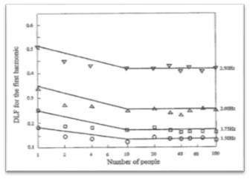

***Figure 15_ DLF of the first harmonic of the force induced by the step frequency and dates crowd number of people in transit (image courtesy of Živanović et al.)***

**A few years later, Živanović [47] performed a statistical analysis of the main parameters that characterize the process of walking (stride length, cadence and gait imperfections) to determine their probability density functions. These were then used to calculate the cumulative probability that the response to the vibrations of a walkway excited by a single pedestrian does not exceed a certain limit value. The probabilistic model obtained from Živanović is mainly suitable for the design of footbridges subjected to light traffic, where there is a single case of prevailing pedestrian load. The main weakness of such a model resided, according to the author, in considering only the first harmonic of the induced force and therefore only one way of vibration of the structure,**

**vibration**

**simultaneously. As a result, the above model based on probability was then extended by Živanović et al.**

1. **​​thus covering not only the main harmonics of ambulation force (ie the force induced by man during the act of walking) but also the subharmonic extras in the frequency domain, as illustrated in figure 16. The gap this extended model, is instead due to the fact that, due to the lack of a measurements database for subharmonic, the corresponding amplitudes of force have been included simply as a function of the first harmonic of the DLF. In addition, with regard to the intra-subject variability, this was represented in the model through the phase angle, uniformly distributed between (-π, π) in the frequency domain.**

**PAGE | 25**

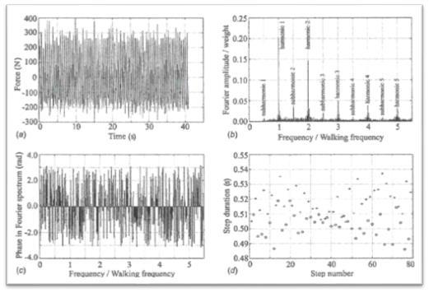

***Figure 16_ (a) History of temporal force induced by a single pedestrian who turns 80 steps on a treadmill, (b) DLF for the main harmonics and sub-harmonics in the frequency domain, (c)***

***phase angle of the forces, (d) walking period as a function of the number of steps (image granted by Živanović et al.)***

**Živanović et al. [48], by applying the modal analysis (the study of the dynamic behavior of a structure when subjected to a** [**vibration)**](https://it.wikipedia.org/wiki/Struttura_resistente) **in order to determine the dynamic** [**properties**](https://it.wikipedia.org/wiki/Vibrazione) **of each mode of vibration, they have developed a model able to calculate the vertical multi-modal response corresponding to ' multi-harmonic excitation of a single pedestrian.**

**Racic and Brownjohn [49] proposed in 2011 a probabilistic model even more advanced. To achieve this, they recruited 80 people of both sexes and characterized by different weights, different heights and ages and were made to walk on a treadmill at a frequency of steps selected depending on the choice of walking speed for each measurement. In this way, they have been collected 824 time histories that show the evolution over time of the vertical component of the force induced by each individual while walking on the treadmill. In Figure 17 it is shown a portion of a temporal history obtained by the measurements.**

**PAGE | 26**

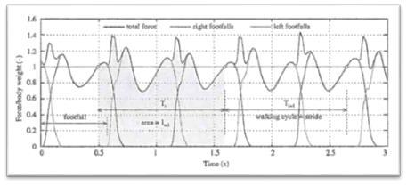

***Figure 17_ Portion of a time history that shows the trend over time of the component vertical force of ambulation (image courtesy of Racic and Brownjohn)***

**As shown in Figure 18, the strength of the signals detected were then divided according to the frequency of steps in 20 clusters each of amplitude equal to 0.1Hz. What the authors noted, it was that most of the range of 1.88 to 1.98 Hz fell signals.**

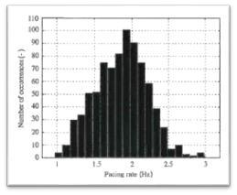

***Figure 18_ measured signals of walking force classified by the step frequency (Image courtesy of Racic and Brownjohn)***

**Following the authors [49], in order to explain the intra-subject variability and therefore the variations in the period of walking cycle ( *T),* They have resorted to a series of dimensionless numbers τ •, such that:**

**τ • = • • - μ •μ •** **; μ • = •••• (• •)**

**The model developed by Racic and Brownjohn [49] also included the calculation of the so-called cycle pulse, defined as the integral of the force on the gait cycle period, normalized for each individual step, in a second moment, to the individual's weight considered.**

**PAGE | 27**

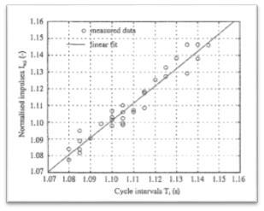

***Figure 19_ Linear regression of the normalized pulse interval as a function of the respective cycle them (Image courtesy of Racic and Brownjohn)***

**Applying a linear regression of the pulse normalized values ​​in function of the corresponding cycle intervals can be obtained a linear relationship as shown in figure 19, which can be modeled as:**

**• •, • = α 0 + α 1 • • + ε •**

**In which • •, • It is the normalized pulse of the cycle *the-* th, ε • It is next to the cycle error**

***the-* th, and α0is α1They are the regression coefficients values ​​of 0.05 to 1.05 respectively.**

**In conclusion, the model developed by Racic and Brownjohn, although very detailed and accurate, is numerically complex and therefore impractical for design purposes.**

***4.1.2.1 The frequency step in probabilistic models***

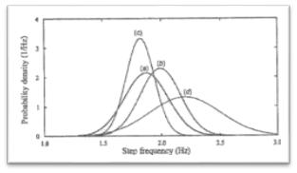

***Figure 20_ Normal distribution of the walk frequency according to (a) Živanović, (b) Matsumoto***

***et al., (c) and Kasperski Sahnaci, (d) and Kramer Kebe (image courtesy of Younis et al.)***

**PAGE | 28**

**Get a reliable statistical description of the step frequency has been under study for several researchers. Among the first was Leonard [50], who proposed the step frequency over the range of 1.7 to 2,3Hz. Subsequently Matsumoto et al. [51], they found, by means of a study conducted on a sample of 505 people, that it followed a normal distribution with mean value of 1,99Hz and a standard deviation of 0,173Hz. After examining 40 individuals, Kerr and Bishop [52] found an average value of 1,9Hz for the step frequency. According to recent studies conducted by Živanović et al. [48] ​​on a sample of 2000 made pedestrians to pass on a catwalk in Montenegro, it was reported, the same way as previous researchers, that the walk frequency follows a normal distribution, but with an average value of 1,87Hz and a standard deviation of 0,186Hz. Finally, other authors such as Kasperski and Sahnaci [53], Pachi and Ji [54], and Kramer Kebe [55] have proposed a mean value of the pitch frequency respectively equal to 1.82,**

**1.8 and 2.2 Hz. It is therefore evident the difference between the average value of the step frequencies found by several researchers over the years, as well as can be seen from Figure 20, pictured above. According Živanović [47], this discrepancy exists by virtue of the fact that each culture has its own customs and ways of life: for example, in Singapore people walk faster than citizens of the United Kingdom [56]. As a consequence of what has been said, Racic et al. [34] have suggested that we need a random sample of people from different cultures, gender and nation in order to perform reliable statistical analyzes.**

**According Pachi and Ji [54], the environment affects not only the step frequency, but also the walking speed. Aforesaid authors have in fact confirmed by a study conducted on a sample of 200 people, that is the frequency of steps that the driving speed are typically greater on floors in shopping centers rather than on walkways. As a consequence, they have developed the following linear relationship between the walking speed *v* and the frequency steps *f:***

**• = • • •**

**in which *THE* *S* It represents the length of the step with the average value equal to 0.75 m for males and 0.67 m for females. Živanović [47], starting from the statistical analysis of data collected by Pachi and Ji, has detected that the walking speed follows a Gaussian distribution at a given step frequency, as presented in Figure 21. Živanović then showed that the well stride length follows a normal distribution with mean equal to 0.71 me standard deviation 0.071 m.**

**PAGE | 29**

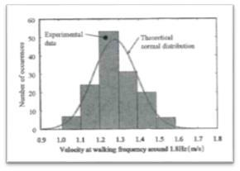

***Figure 21_ Distribution of normal walking speed to a pitch frequency of 1.8Hz (Image courtesy of Živanović et al.)***

**Subsequently, Yamasaki et al. [57] conducted a study to investigate the relationship between the various parameters of the walk considering the gender of the person. As can be seen from Figure 22, the authors have found a non-linear behavior between the walking speed and the stride length, as it had been studied by previous authors. More precisely, this non-linear behavior at high speed verification of walking and, in particular, at such speeds, the step length is shorter for females than males. In general, therefore in order to increase the walking speed, the females increase the frequency of steps while the males increase the length of the steps.**

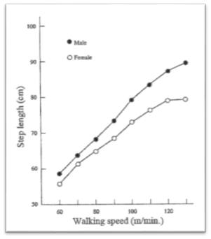

***Figure 22_ Behavior of stride length to vary the walking speed (image granted by Racic et al.)***

**PAGE | 30**

**4.2 MODELS OF FORCE IN THE FREQUENCY DOMAIN**

**The dynamic forces induced by man while walking can be expressed in the frequency domain, ie in terms of amplitudes obtained for sine waves and cosine corresponding through the decomposition of the Fourier transform [58, 59]. Ohlsson [29], in his PhD, he measured a single foot strength and then repeated it for the time history of a continuous induced force, assuming a perfect periodicity. What emerged from the analysis of this continuous walking force, it was that a single step retains most of its excitation energy in the frequency range 0 Hz and 6 Hz. In addition, the self-determined spectral density (ASD) of force considering the latter as a transient signal resulting from a series of steps perfectly repeated but in limited numbers. Ohlsson's study focused on the behavior of high frequency floors (ie frequencies 6-50 Hz), as the subject of his studies. A few years later, Eriksson [60] further developed the approach developed by Ohlsson to investigate the strength of continuous journey in the frequency domain in the case of low frequency floors (frequencies between 0 and 6 Hz). Figure 23 shows a part of the spectrum of a continuous force measured for a period of approximately 100 seconds and highlights what is known as a loss in each peak. This loss, produced by the fact that the excitation energy content of at integer multiples of the pitch is spread frequency in adjacent frequencies, it indicates that the strength of the human journey can not be perfectly periodic and, therefore, can not be described accurately by means of a model in the domain weather. Earlier, Rainer et al. [38] During their investigation of the dynamic load induced on a catwalk as a pedestrian, they had highlighted these imperfections. The human gait, according to Eriksson, should therefore be described as a stationary random process. during their investigation of the dynamic load induced on a catwalk as a pedestrian, they had highlighted these imperfections. The human gait, according to Eriksson, should therefore be described as a stationary random process. during their investigation of the dynamic load induced on a catwalk as a pedestrian, they had highlighted these imperfections. The human gait, according to Eriksson, should therefore be described as a stationary random process.**

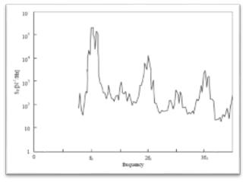

***Figure 23_ auto-spectral density relative to the force-induced gait (image granted by Živanović et al.)***

**PAGE | 31**

**A step forward was made by Brownjohn et al. [61], which have shaped the vertical component of the induced force on pedestrian structures by means of the approach of the spectral density. The authors recruited three test subjects asked to walk on a treadmill at a rate of self-selected pace with speeds between 2.5 and 7.5 m / s. In this way were obtained, in reference to each of three individuals, a sequence of time histories of a minute walking together with the corresponding step frequencies and typical parameters of the walk. These results were then compared with those derived from models based on the assumption of perfect periodicity to demonstrate their inadequacy and thus highlight the effect of intra-subject variability. About that, consider the figures illustrated below. Both show the Fourier amplitudes, normalized with respect to body weight, for the modeling of the induced force, at a frequency of 1,9Hz. In Figure 24_a represented the force is that deterministic estimated through its harmonic components while 24_b is reproduced in the signal strength of the actual walking recorded for the same weight and pitch frequency of the subject. Comparing them, it is observed that there is a scattering of energy in the case of induced deterministic force with respect to the case of actually measured force, especially for higher harmonics. In Figure 24_a represented the force is that deterministic estimated through its harmonic components while 24_b is reproduced in the signal strength of the actual walking recorded for the same weight and pitch frequency of the subject. Comparing them, it is observed that there is a scattering of energy in the case of induced deterministic force with respect to the case of actually measured force, especially for higher harmonics. In Figure 24_a represented the force is that deterministic estimated through its harmonic components while 24_b is reproduced in the signal strength of the actual walking recorded for the same weight and pitch frequency of the subject. Comparing them, it is observed that there is a scattering of energy in the case of induced deterministic force with respect to the case of actually measured force, especially for higher harmonics.**

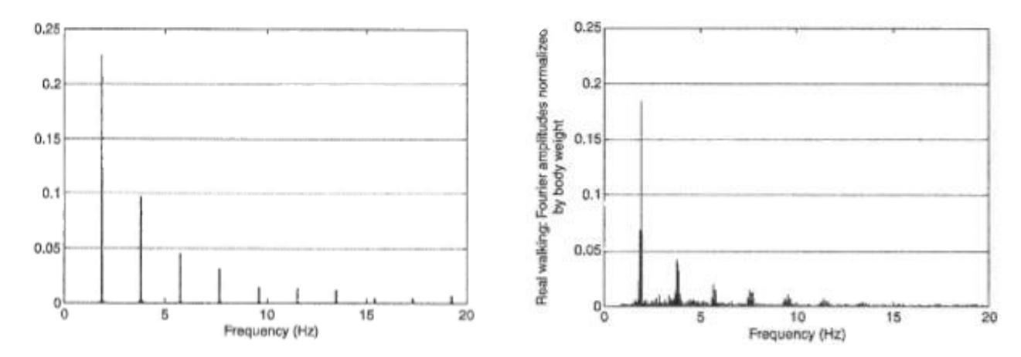

**(to)** **(B)**

**Figure 24_ (a) Representation *of deterministic strength and simulated-induced while walking in the frequency domain (* b) *Representation* *of the real gait force and continues represented in the frequency domain (image courtesy of Brownjohn et al.)***

**As evidence of this, the modeling of the vertical component of the induced force using the classical deterministic approach is inaccurate. As a result of such evidence, Brownjohn et al. have proposed a modeling approach in the frequency domain is valid for an individual or for a crowd, based on ASD function.**

**Subsequently, Sahnaci and Kasperski [62] stated that the cause of the imperfections in the biped walking model lies in the presence of intermediate amplitudes, so-called sub-harmonics, which retain a relatively significant portion**

**PAGE | 32**

**of excitation energy between the harmonics of the main frequency bands (0.5 *f* *w,* 1.5 *f* *w,***

**etc.), as shown in Figure 25. The presence of such subharmonic is the consequence of the inevitable difference between the right foot and the left in terms of gait parameters such as the pitch frequency and the stride length.**

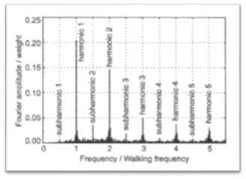

***Figure 25_ Representation of the amplitudes of the subharmonics of the force induced by man in the frequency domain (image courtesy of Živanović et al.)***

**PAGE | 33**

**5 Statistical model developed**

**In this paragraph we intend to examine the results obtained from the data analysis collected through measurements made on a floor of strength. The purpose is to identify a mathematical model of probabilistic type for bipedal walking. The variables taken into consideration are four: time between a step and the next, force discharged to the ground by the pedestrian during a step, stride length and angle of the step with respect to the direction parallel to the centre line of the walkway.**

**It must be emphasized that during this research three limiting factors were involved more remarkably. First the time: this is one of the main elements for bring this experimental study to a high quality standard. Second place, quality and quantity of data: the number of subjects tested was limited to three because, as aforesaid, of time. Also during the measurements, the walk carried out by the test subjects it was in a certain sense “guided”: in order to withdraw data in disaggregated form (ie data for the right foot and data for the left foot), it was necessary, in fact, to walk near the centre line of the**

**floor of strength and, therefore, the data do not faithfully represent the methods of a spontaneous walk. Finally, a critical factor was that relating to literature: the probabilistic type models developed for bipedal walking are relatively few and present several critical issues.**

* 1. **MARKOV PROCESS**

***“A Markov chain is a random process with the property that, conditional on its present value, the future is independent of the past”***

**The developed model is implicitly based on the Markov process: in fact it is based on the hypothesis that each step 𝑃𝑘 depends only on the step taken at the time 𝑘 - 1. The Markov process, as introduced in the quotation at the beginning paragraph, is a random process in which the probability of passing from one state to another of the system depends only on the state immediately preceding and not on overall "history" of the system. Consider a process 𝑡 → 𝑋(t). Here 𝑡 represents time and 𝑋 (𝑡) is the state of the system at time. The variable 𝑋 (𝑡) assumes values in a space 𝕏, called "state space" of the process. The property that defines the Markov process is expressed by saying that whatever the positive integer 𝑛, whatever the sequence of instants 𝑡0 <𝑡1 <⋯ <𝑡𝑛 − 1 <𝑡𝑛 and states 𝑥0, 𝑥1, ⋯ 𝑥𝑛 − 1, 𝑥𝑛 ∈ 𝕏, we have that:**

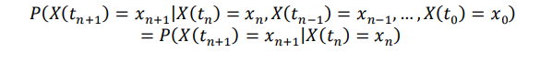

**1 Geoffrey Grimmett and David Stirzaker, " *Probability and Random Process* "III ed., Oxford, p.213. Italian translation by the undersigned " *A Markov chain is a random process with the property that, based on its current value, the future is independent of* *the past.* "**

**PAGE | 34**

**In which P {A | B} indicates the probability of the event A conditioned by the realization of the event B. Thus, the conditional probability ℙ (𝑋 (𝑡𝑛 + 1) = 𝑥𝑛 + 1| 𝑋 (𝑡𝑛) = 𝑥𝑛) represents the probability of transition to the state 𝑥𝑛 + 1 assuming that the process takes place you find in the state 𝑥𝑛 in the previous instant. This property is also called condition of "absence of memory".**

**If time is assumed in discrete form, then the Markov process will be represented by a sequence of variables (𝑋𝑘)𝑘 that satisfy the condition:**



**In this model the transition probability does not depend on time. For this reason the process is called "stationary".**

**It should be noted that, albeit minimal, of dependence required between a step and the other represented by Markov property is in some models replaced by total independence. It therefore assumes that:**



**So the process will be a sequence (Xk)k of identically distributed independent variables. Some examples of this kind are known in the literature as "random walk" ( " *random walk* "). It is designed very discrete time processes, both for the intrinsic interest and as basic models for the study of physical phenomena such as the spread. In *random walk* two-dimensional** (𝑃𝑘 )k**, the space is represented by the lattice points in the entire plane coordinates $Z^{2}$. Walker located at a point** 𝑥 = (𝑖,𝑗) **of the grating, you can only go to one of the 4 neighboring points** 𝑥1 = (𝑖 + 1,𝑗), 𝑥2 = (𝑖,𝑗 + 1), 𝑥3 = (𝑖 − 1,𝑗), 𝑥4 = (𝑖,𝑗 − 1) **and it does so with probability equal to each other, and therefore with probability 1/4. The representation of this process, may be obtained by considering the sequence of displacement vectors from one location to the next:**

𝑣⃗𝑘 = 𝑃𝑘+1 − 𝑃k

**evidently $\vec{v}k ∈ X = \{(1,0), (0,1), (-1,0), (0, -1)\} e (v⃗k )k$ will be the sequence of independent identically distributed random variables, with**

ℙ( 𝑣⃗𝑘 = 𝑥) = 1/4

**whatever it is** 𝑥 ∈ 𝕏.**The Walker's position at the time k will be known from the initial position P0 and by the sequence ( vk)k thanks to the relation**

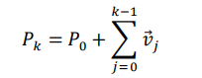

**In general, the pattern of *random walk* You do not apply to the walk of an individual. In fact, since the choice of direction of the step and with random**

**PAGE | 35**

**uniform distribution, the model does not allow to represent a path regulated by the walker's determination to move from a given point of departure to a fixed arrival (for this reason the model is described as the walk of a drunk). On the other hand, the position space 𝑃𝑘 is evidently continuous. This makes the treatment of the model complicated assuming discrete time, due to the need to have to represent the probabilities of transition, as conditional probabilities of absolutely continuous random variables.**

**Let us therefore consider a walk given by a sequence of successive positions 𝑃0, 𝑃1, ... 𝑃𝑘,… Introducing, as in the random walk, the vectors 𝑣⃗𝑘 = 𝑃𝑘 + 1 – 𝑃𝑘 , that can represent the walk through the sequence 𝑃0, 𝑣⃗0, 𝑣⃗1, ..., 𝑣⃗𝑘, … is**

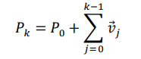

**The difference with respect to the RW consists in the fact that in that case the vectors 𝑣⃗0, 𝑣⃗1, ..., 𝑣⃗𝑘,... are uniform variables in the discrete set of the 4 directions 𝕏 = {(1,0), (0,1), (−1,0), (0, −1)}, while in the present case these are variables continuous and not uniformly distributed. The details will be shown in the following section.**

**PAGE | 36**

**5.2 REPORT STRIDE AND ANGLE OF STEP**

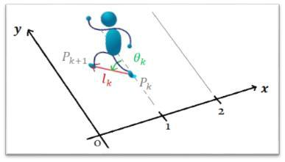

***Figure 26_ Cartesian Reference by step Man***

**Each carrier** 𝑣⃗𝑘 = 𝑃𝑘+1 – 𝑃k **can be represented in polar coordinates** (𝑙(𝑘), 𝜃(𝑘)) **- length and pitch angle k- th respectively. The vector** 𝑣⃗𝑘 **can therefore be identified with the couple length angle** (𝑙(𝑘), 𝜃(𝑘))

**In the image shown above (figure 26), the reference system is represented in which the length and angle of the step k are reproduced, both positive.**

**As mentioned earlier, we assume that the vectors** 𝑣⃗𝑘**, and therefore couples** (𝑙(𝑘), 𝜃(𝑘)) **are identically distributed (ie that their distribution does not depend on k). Let f(l, θ) the joint probability density function of length and angle. Evidently this independent step model can represent reasonably well the walk on the pathway, if the distribution f(l, θ) will be able to assign probabilities to walks that take place approximately in a direction parallel to that of the walkway, with the direction of travel which goes from one end to the other. On the other hand, small paths that take place in different ways will have to be probable, for example with long stretches in a transversal direction to the walkway or with changes in the direction of travel (ie with both direct and retrograde phases of motion). A distribution of this kind will be able to realize comminate similar to those of a rational human walker (therefore not drunk), even with the independence between one step and the next.**

**A second observation relates to the independence of the length and angle variables. The assumption of this property leads to a noticeable simplification of the model, without being, however, too far removed from reality. Analysis of the data is in fact showed a certain degree of independence between these two variables (see Appendix 2).**

**PAGE | 37**

**Therefore, the joint probability density function f(l, θ) It will be equal to the product of the density functions of the individual random variables. That is:**

𝑓(𝑙, 𝜃) = 𝐴(𝜃) 𝐿(𝑙)

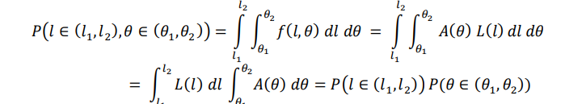**Where is A and L are respectively the probability of continuous random variables density functions θ (Angle of pitch") and l ( "Stride length"). As a result we have that the probability that the stride length is between l1 and l2 and the angle of the step is between θ 1 and θ 2 is:**

**In the following two subparagraphs the data "step length" and "step angle" relating to one of the three test subjects will be examined, emphasizing that the statements and reasonings reported have been validated by the data relating to all three subjects tested.**

**5.2.1** **Step length**

**Let us now consider in detail the continuous random variable "step length" l. From the graph shown in Figure 27, one can identify a trend of the same next to that of a so-called "normal" distribution or Gaussian. This graph is obtained by the command " *histogram (X, nbins)* " in Matlab which returns a number of rectangles specified by the scalar, *nbins* to cover the range of elements of *X (* where is it *X* in this case is the vector containing the step lengths) and reveal the underlying shape of the distribution. The height of each rectangle indicates the number of data related to X that fall within that range of values.**

**PAGE | 38**

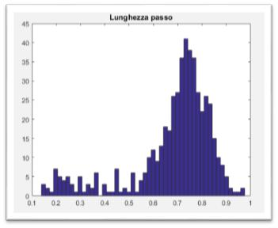

***Figure 27_ stride length results***

**Analyzing the graph, what, in a sense, "disturbs" the typical behavior of a Gaussian is the presence of between 0.1 and 0.4m lengths with a far-zero probability density function. This stems, as anticipated at the beginning of paragraph, the limitations imposed by the force of the floor on which the measurements were made. The strength of the floor allowed a very limited number of steps given its length (5 meters) and the test subject was required to walk on the floor for about 30 minutes. Therefore, values ​​between 0.1 and 0.4m in the chart with enough relevant density function correspond to those steps carried out close to the top and bottom edges of the walkway, resulting inversion of the walk.**

**In Matlab, by means of the function " *normplot* "You can visually assess whether the data in a vector X from a population with a normal distribution. Applying this function to the vector containing the lengths of each step performed by the test subject is obtained by the following chart:**

**PAGE | 39**

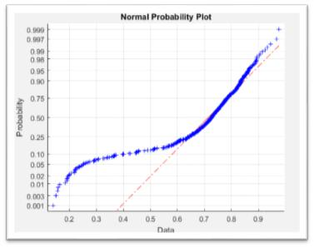

***Figure 28_ Percentiles on stride length compared with those of a normal distribution***

**The function " *normplot* "Produces the so-called *normal plot,* where precentili derived empirically from a set of data are compared with those of a normal distribution (or Gaussian) distribution with mean and variance equal to those estimated from the data. In that graph, a set of data from a normal distribution will therefore be perfectly aligned on a straight line (the red line in Figure 28). In the case of figure 28 it is noted that the values ​​between 0.6 and about 0.9m, follow a normal distribution, as opposed to values ​​between 0.1 and 0.4m that, in fact, correspond to the steps performed in the vicinity of the edges of the floor of power. These values ​​measured in correspondence with the top and bottom edges of the walkway, are " *outliers* ", Where for *outlier* is defined as a given that it is at a distance greater than three standard deviations from the mean (or median).**

**PAGE | 40**

**If, therefore, we represent the trend of pitch lengths, removing the data *outliers,* histogram is as follows:**

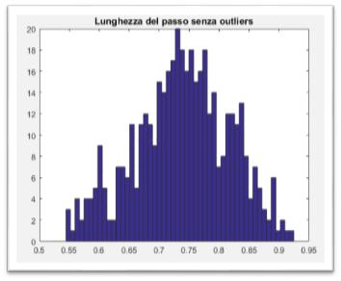

***Figure 29_ Performance of the step length without outliers***

**As can be visually observed from Figure 29, the data between 0.1 and 0.4m are rightly eliminated, since considered the result of an "error" caused by the limitations imposed by the structure used to make the measurements. Once the deleted data *outliers* from the vector containing the step lengths can again use the function " *normplot* "To see if indeed the remaining data from a population with a normal distribution. You obtain the following graph (Figure 30) confirms that precisely what was expected:**

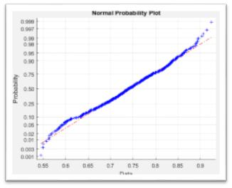

***Figure 30_ Percentiles on stride length without outliers compared with those of a normal distribution (or Gaussian)***

**PAGE | 41**

**5.2.2 Step Angle**

**Finally, analyze the trend of the second random variable in question, ie the angle of the step θ. The graph of Figure 31, below, shows a trend of the same that follows a bimodal distribution, as rightly we should expect since the step of the right foot and the left foot imprint a small drift to walk in two specular directions (towards right / left-side). This alternating behavior is represented by a sequnza of Agoli θ (0),**

* **(1), ... θ (•) ... signs alternate. The condition that the driving direction is (almost) parallel to the length of the walkway (not drunk walker), will be ensured by the condition that the average of the variable θ is approximately zero. With regard to the graph of Figure 31, the average is in fact equal to 0.0317.**

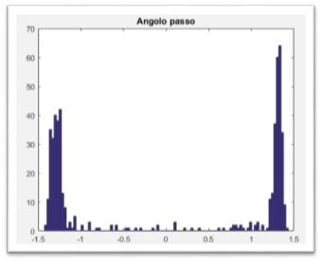

***Figure 31_ angle of the step results relative to a test subject***

**Then we evaluate, respectively, the conditional probability density functions • (θ | θ> 0) is • (θ | θ <0) to see if their progress is approximated by a Gaussian distribution. In other words, the variable condizioniamo θ to assume positive values ​​in one case and negative values ​​in the other.**

**PAGE | 42**

**THE.** **• (θ | θ> 0)**

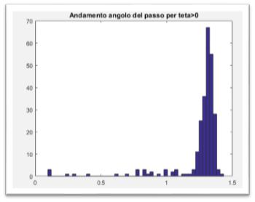

***Figure 32_ angle of the step results for* θ> 0**

**then we apply the function " *normplot* "Angle to these pitch values, thereby obtaining the graph of Figure 33.**

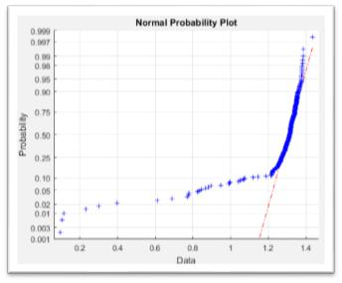

***corner of Figure 33_ step Percentiles for* θ> 0 *compared with those of a normal distribution***

**We can therefore ascertain that, except for the values ​​of the edge, the angle of the step forθ> 0 It follows a normal or Gaussian distribution. We check whether this also applies to**

**θ <0.**

**PAGE | 43**

1. **• (θ | θ <0)**

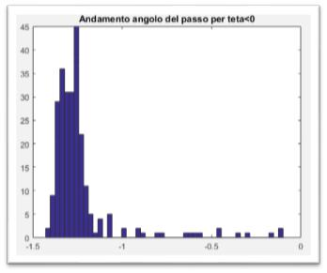

***Figure 34_ angle of the step results for* θ <0**

**By applying the function " *normplot* "In this series of values ​​of the angleθ <0 ( figure 35) one can draw the same conclusions as the previous case with θ> 0.**

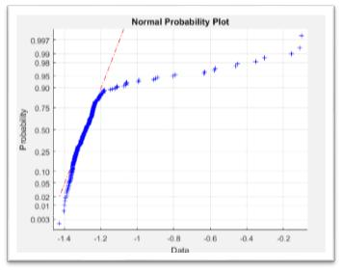

***corner of Figure 35_ step Percentiles for* θ <0 *compared with those of a normal distribution***

**PAGE | 44**

**As for the step lengths, even in the case of the corners you can try to eliminate outliers to see if what remains is better represented by a normal or Gaussian distribution. If we represent the angle course θ for**

**θ> 0 is θ <0, removing data *outliers,* They are respectively the two histograms (Figure 36) shown below:**

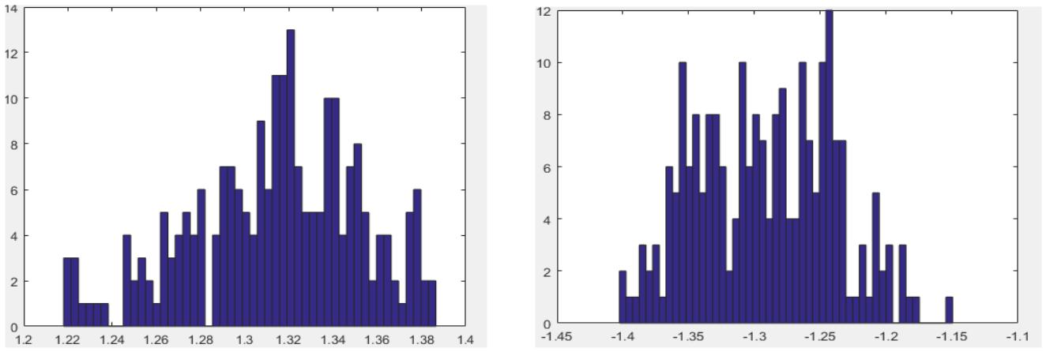

**(to)** **(B)**

***Figure 36_ (a) of the angle results for* θ> 0 *after the removal of outliers data (b) Development angle for* θ <0 *after the removal of outliers data***

**It can thus be visually verify that the values ​​between 0 and 1.2, in the case ofθ> 0 and between 0 and -1.1, in the case of θ <0, They were eliminated, as considered *outliers***

**and then deviant values. Once these data deleted from the vectors containing the pitch angles respectively for θ> 0 and pitch angles for θ <0, You can apply the function " *normplot* "To understand, as aforesaid, if the residual data actually come from a population with a normal distribution.**

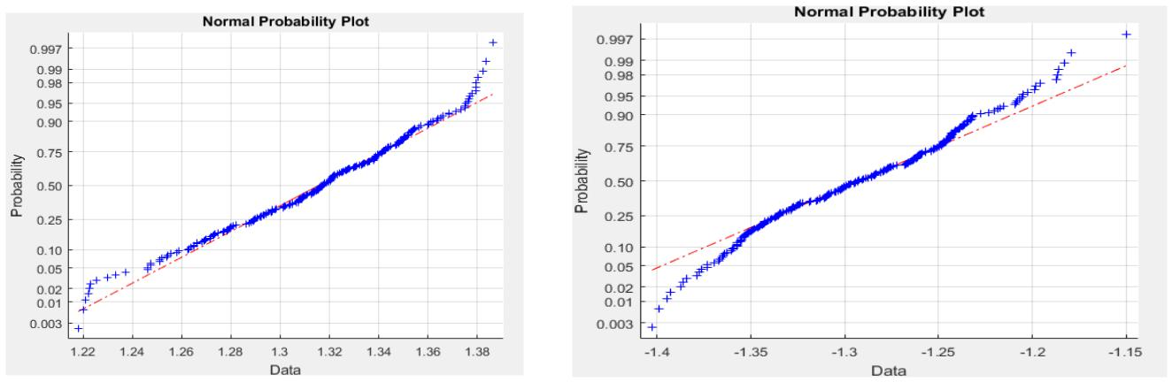

**(to)** **(B)**

***Figure 37_ (a) Percentiles corner of the step for* θ> 0 *compared with those of a normal distribution***

***(B) the percentile corner of step* θ <0 *compared with those of a normal distribution***

**PAGE | 45**

**In both cases, the angle data, after the application of the function " *eliminaoutliers* "Created in Matlab, they have a reasonably Gaussian behavior: most empirically derived percentiles from the set of reference data (ie data on θ> 0 it's at θ <0) They are in fact arranged on the red line.**

**Consequently, we can affirm that, globally, the variable "corner of the step" is certainly not Gaussian, however, conditioning to assume positive values ​​or negative values, and removing data*outliers,* then this follows roughly a normal distribution. Thus we can describe the distribution of**

**θ**

**substantially as the superposition of two normal random variables each having its own mean and variance. In particular, the mean and the variance of the angle distribution θ in two cases:**

**the)** **• (θ | θ> 0) •••• = 1.3139** **•** **••• = 0.0015**

**ii)** **• (θ | θ <0) •••• = -1.2920 •** **••• = 0.0028**

**We conclude stressing that the data confirm the 'assumption, discussed at the end of the previous section, that the distribution of the angles has a non-uniform pattern and such as to maintain the direction of gear coherent with that of the walkway.**

**PAGE | 46**

**⃗⃗⃗⃗⃗⃗⃗⃗⃗,• •)**

**5.3 REPORT STRONG PITCH AND TIME OF STEP**

**A second report which has been identified following analysis of the experimental data, concerns the negative correlation between the strength and time variables (see Appendix 2). In reference to the latter variable, it refers to the interval of the time given by the step duration. Reasoning in terms of strength discharged to the ground during each step, it is indeed considered appropriate to consider the time not in absolute terms, but relative to a single step. The negativity of the correlation implies that as the time between one step and the next, decreases the force discharged to the ground during a step and, conversely, to decrease the time, increases the discharged force.**

**We are therefore in the presence of a two-dimensional process such that a variable varies as a function of another. In particular, it has a variable *n* identifying the number of steps taken by a person and a carrier consisting of two data ( Δ• •**

**which substantially corresponds to a random vector in which Δ• • is • • are both continuous random variables related to the n-th step. It is assumed that the joint probability distribution of this random vector is stationary, that is the same for all • ( therefore independent of •). Therefore, the joint probability density function is:**

**• ( Δ•, • )** **••• Δ• ≥ 0, • ≥ 0**

**Being Δ• • • dependent on each other, the joint probability density function, unlike the previous report, not factored. You can using the command " *histogram2 (X, Y, nbins)* "Present on Matlab, to create a chart of the two-dimensional variable histograms (X, Y), where in this case, X corresponds to the carrier containing the data on the time and Y to the vector containing the data on the strength. This command returns a number of rectangles in 3D equal to the square of *n* bins, chosen to cover the range of elements in X and Y, and reveal the underlying shape of the distribution. The height of each bar indicates 3D, in this specific case, the number of occurrences of pairs ( Δ• •**

**⃗⃗⃗⃗⃗⃗⃗⃗⃗,•• ) that fall in**

**that interval of time values ​​and strength. It therefore obtains the following graph (Figure**

**38):**

**PAGE | 47**

**⃗⃗⃗⃗⃗⃗⃗⃗⃗,••**

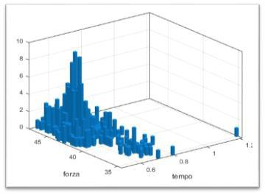

***Figure 38_Andamento time vector-force***

**This plot can be done by applying different colors to highlight the two-dimensional random vectors ( Δ• •**

**) with highest joint probability density (Fig. 39).**

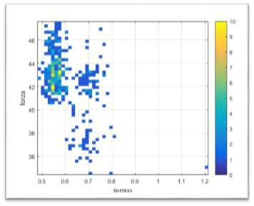

***Figure 39_ time-force vector patterns with frequency of pairs of different colors***

**As a next step, you can define the marginal density functions for each variable as follows:**

**+ ∞** **+ ∞**

**• Δ• ( Δ• ) = ∫ • ( Δ•, • ) ••** **,** **• • ( • ) = ∫ • ( Δ•, • ) •Δ•**

**0** **0**

**We estimate, therefore, as the random variables are distributed Δ• • is • •, independently of each other.**

**PAGE | 48**

**5.3.1** **Pitch Time**

**We can analyze the marginal density function of time (defined as the duration of each step) by analyzing the column of the times that is obtained through the elaboration of experimental data. Then we go to graphically represent the time variable (Figure 40):**

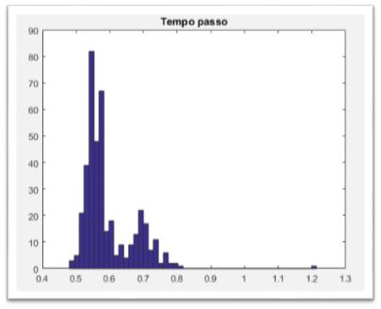

***Figure 40_ of the time variable results***

**The graph shows an asymmetrical performance because the data are not evenly distributed on both sides of the peak. In particular, the mean and the variance of this distribution are respectively 0.5948 and 0.0059.**

**PAGE | 49**

**then apply the function " *normplot "* to see if this hypothesis is confirmed or not:**

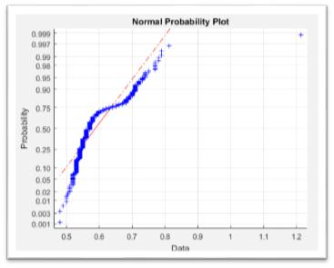

***Figure 41_ Percentiles on time compared with those of a normal distribution***

**The Figure 41 graph actually shows that most of the data is not on the red line, that is, does not come from a normal distribution. In conclusion, time**

**Δ• , duration of a step is not distributed evenly.**

**5.3.2 Pitch Force**

**Finally, we analyze the marginal density function relative to the induced force during each step performed by the test subject. The graph of Figure 42, shows a pattern of the latter variable that might reasonably approximate that of a normal distribution if it were not for the presence of the tail of values ​​between 0 and 40Kg that turns out to be quite evident.**

**PAGE | 50**

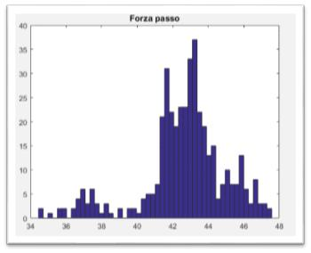

***Figure 42_ of force results***

**therefore we apply the function " *normplot "* to see if this trend approximates, at least for the central values, to a population with a normal distribution with mean and variance equal to those estimated from the data (mean and variance are respectively 5.5919 and 42.6344). Unlike the "time" variable which showed clearly that the majority of the data was outside the red line that identifies a population with normal distribution, in this case a quite considerable part of the data lies on this straight. In particular, as you can be seen by taking vision of the figure 43, the data portion comprised between 41 and 45Kg approximately follows a Gaussian distribution.**

**PAGE | 51**

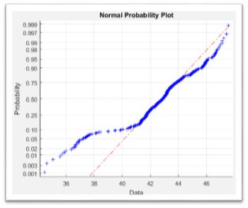

***Figure 43_ Percentiles on strength compared with those of a normal distribution***

**You can, therefore, try to apply the function " *eliminaoutliers* "To see if what remains is best represented by a normal or Gaussian distribution. If we represent the evolution of force by removing the data considered *outliers,* You obtain the following graph (Figure 44):**

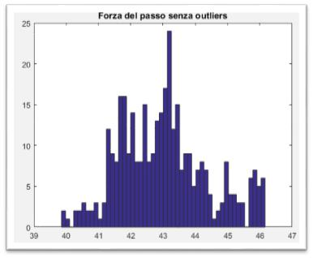

***Figure 44_ of force results induced without outliers***

**As a consequence of this, we note that the values ​​at the edges, ie those between 34 and 39 and between 46.5 and 48 have been eliminated, since considered *outliers.* Once deleted**

**PAGE | 52**

**such data, one can apply the function " *normplot* "To understand, as mentioned above, if the remaining data better follow a normal distribution.**

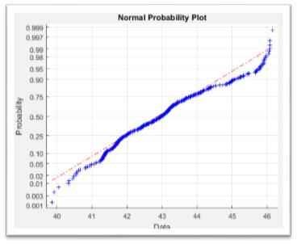

***Figure 45_ strength results compared with that of a normal distribution***

**In the light of the Figure 45 graph, the force data, private outliers, roughly follow a normal distribution: most of the percentiles empirically derived from data relating to the force are in fact arranged on the red line.**

**PAGE | 53**

**5.4 REPORT TIME OF STEP AND STRIDE**

**The last appreciable relationship that has been identified following analysis of the experimental data, concerns the correlation, even a negative time, between the variables of the stride length and time (see Appendix 2). Therefore the two variables affect each other in the sense that as the time between one step and the next, decreases the length of the step and, conversely, to decrease the time, increases the length of stride. Again we are in the presence of a two-dimensional process where the random vector consists of two data ( Δ• •**

**⃗⃗⃗⃗⃗ ⃗⃗⃗⃗,• •)**

**in which Δ• • is • • are two continuous random variables related nth step. The joint probability density function is:**

**• ( Δ•, • )** **••• Δ• ≥ 0, • ≥ 0**

**Being Δ• • • dependent on each other, the joint probability density function is not factored. We are**

**therefore the performance of the random vector two-dimensional ( Δ• •⃗⃗⃗⃗⃗⃗⃗⃗⃗,•• ) to try to understand what are the pairs of time- values**

**stride length that occur with greater frequency. It is obtained, through the command " *histogram2 ()* ",**

**The graph below (Figure 46):**

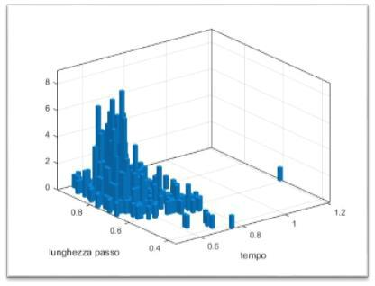

***Figure 46_ long-length step vector performance***

**PAGE | 54**

**⃗⃗⃗⃗⃗⃗⃗⃗⃗,••**

**This plot can be done by applying different colors to highlight the two-dimensional random vectors ( Δ• •**

**) with highest joint probability density (Fig. 47).**

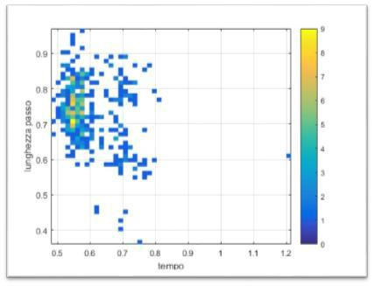

***Figure 47_ long-length step vector patterns with frequency of pairs of different colors***

**PAGE | 55**

**6 Data analysis**

**In this section, we intend to define the manner in which the measurements were carried out, and with which, subsequently, have been reworked for the purposes of modeling.**

**6.1 UTLIZZATA INSTRUMENTS**

**Data collection for this research was conducted in the Department of Engineering of Enzo Ferrari in Modena. A strong floor equipped with a sensor system was used to record the variables of interest. In particular, the structure used to make the measurements consists of ten plates, each of area**

**1• 2 , stainless steel and covered with waterproof mats made of synthetic material steel. The force plates were arranged so as to form an area 2•5 for a total of 10• 2 of available surface, as illustrated in Figure 48.**

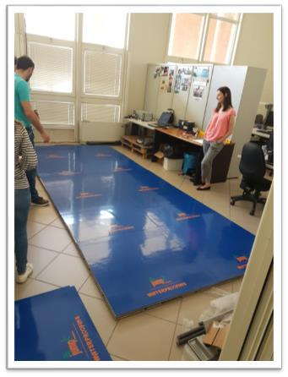

***Figure 48_ Floor force used to make the measurements***

**PAGE | 56**

**Beneath each plate of the floor strength they were positioned four load cells, one in each corner of the plate (Figure 49). Subsequently, the load cells have been connected to a control unit which, in turn, was connected to a computer.**

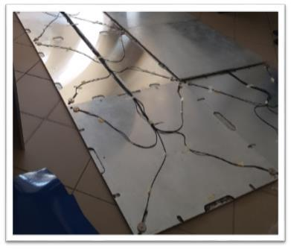

***Figure 49_ load cells at the corners of each of force plate***

**6.2 SOFTWARE FOR DATA ACQUISITION**

**The software, installed on the computer, which is used for the acquisition of data, and thus for the control of each plate of the strength of the floor, is *Labview.* This design software is designed specifically for the development of test and measurement applications with quick access to the results. In figure 50 it is shown the interface on the acquisition computer the measurement through the above software. In this figure are shown two boxes: one green contains buttons necessary to initiate the plates, while the red shows the data acquired at intervals of milliseconds, and the graph of the plates with the location. In order that the recorded data are disaggregated, ie relative to each foot, the right plates (indicated in the figure with "P2") record the data separately from those of the left (indicated by "P1"). If both feet were in fact they registered the same four load transducer,**

**PAGE | 57**

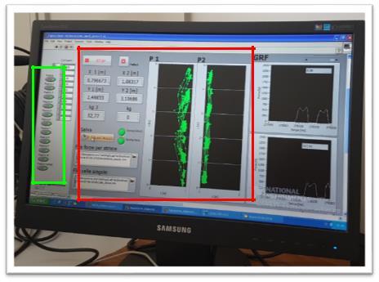

***Figure 50_ Labview software interface***

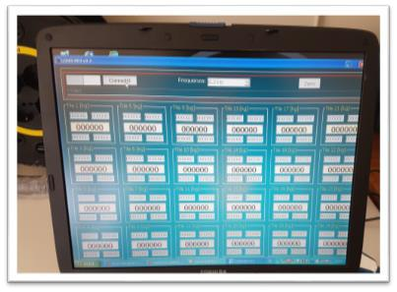

***Figure 51_ interface LCDAs program***

**The software *labview* produces *file.lvm* which can be converted in format *excel.* Data from *output* contained in these files they are: the time, equal to an interval of milliseconds between capture and the next (this is dependent on the sampling frequency, equal to 50Hz, selectable on LCDAs program whose interface**

**PAGE | 58**

**is shown in Figure 51 soprariportata), the force expressed as the weight in Kg discharged onto the ground by each foot (there are about 5kg of deviation from the actual weight), the location • and position •, expressed in meters, of each foot relative to a reference system. The latter is shown in Figure 52. From this image it can be deduced, therefore, that the position • Foot can assume values ​​in the range0,2][ while the position • values ​​in the range0[.5].**

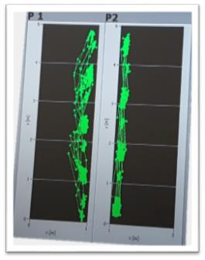

***Figure 52_ reference system to identify the location of each foot***

**6.3 CRITICAL FACTORS IN THE DATA COLLECTION**

**The data collected in this study was conditioned by several factors, some already discussed at the beginning of paragraph 5, which should be deepened. As already mentioned, the data relating to the right and left plates plates were acquired separately. To allow for this, the walk of each subject tested was "guided" straddling the center line of the floor (and therefore around • = 1•).**

**Secondly, it must be emphasized that the plates of the strength of the floor could produce noise during recording because of their extreme sensitivity data. The software *labview* in fact it showed small variations in the force induced on certain plates where there would be due. Thirdly, we were interested in what was mainly the correlation between the time variables (in the sense of the duration of a step), discharged strength during a step, length and angle of the step. For the purposes of statistics it was therefore necessary to have a lot of data on many people taken individually, and without walking one by one on the floor of strength. Since this study to a stage still quite primitive and therefore necessitating**

**PAGE | 59**

**increasingly elaborate future research, the number of test subjects was limited to three. The three subjects tested differed in height and in proportion to the height, weight. In addition to varying the speed, as is known from the literature, it changes the shape of the step, whereby a metronome to obtain time histories of the fixed-step cadence was used.**

**6.4 RE-DATA**

**The data recorded by *labview* They were subsequently processed through the creation of a program**

**implemented in Matlab. For each subject tested two acquisitions were made, each lasting about 15**

**minutes. The data for each acquisition, saved in files of type ". *lvm* ", They were then converted to files." *.xlsx***

**"To finally be manipulated on Matlab. Below is the code developed commented:**

**clear all**

**x = xlsread ( 'Prova1Jessica' ); isx = find (x (:, 4) == 0 & x (:, 5) == 0); % X and y position of the foot on the left plates**

**idx = find (x (:, 7) == 0 & x (:, 8) == 0); % X and y position of the foot plates on dx**

**iforzadx = find (x (:, 6) <5); % Strength recorded on plates even if dx**

* + - **The person does not walk**

**iforzasx = find (x (:, 3) <5); % Strength recorded on sx plates also**

* + **If the person does not walk**
* **I reset all the rows of the matrix with unnecessary data (strength <5Kg) or zero**

**x (isx, 3) = 0; x (idx, 6) = 0; x**

**(iforzadx, 6) = 0; x (iforzadx, 7)**

* **0; x (iforzadx, 8) = 0; x (iforzasx, 3) = 0; x (iforzasx, 4)**
* **0; x (iforzasx, 5) = 0;**

**i1 = find (x (:, 4) ~ = 0 | x (:, 7) ~ = 0); % Delete rows with data of both feet (1st approximation)**

**y = x (i1, [1,3: 8]); % I take off the column 2 which is a counter (number of acquisitions that depends on the choice of sampling frequency (50Hz)**

**i2 = find ((y (:, 3) ~ = 0 & y (:, 6) == 0) | (y (:, 3) == 0 & y (:, 6) ~ = 0)); z = y (i2, :); % Z is the new matrix in which I blocks with data only for dx plates or data relating to the sun sx plates without overlapping**

**clear x**

**clear y**

**% Variables necessary for calculating the average of the% data of each block or dx sx**

**PAGE | 60**

**iniziobdx = zeros (500.1); 500% is the maximum number of blocks right**

**iniziobsx = zeros (500.1); 500% is the maximum number of blocks left**

**finebdx = zeros (500.1); finebsx = zeros**

**(500.1); pos = zeros (500.1); v = zeros**

**(500.7);**

**jbdx = 0; jbsx = 0; ib = 0;**

**if (Z (1,5) ~ = 0) % If in the first row of z I x dx of different plate**

**0% then there begins the first block**

**jbdx jbdx = + 1; ib = ib + 1; pos = + 1; % Ie first step done by the right foot on the plate**

**iniziobdx (jbdx) = 1;**

**end if (Z (1,2) ~ = 0) % If in the first row of z I x of the different plate sx**

**% Different from 0 then there begins the first block**

**jbsx jbsx = + 1; ib = ib + 1; pos = -1; % Ie first step done by the foot on the left plate**

**iniziobsx (jbsx) = 1;**

**end**

* **I find where it ends each data block for i = 2: length (z)**

**if (Z (i-1,5) == 0 && z (i, 5) ~ = 0) = jbdx jbdx + 1; ib = ib + 1; iniziobdx (jbdx) = i;**

**end if (Z (i-1,5) ~ = 0 && z (i, 5) == 0) finebdx (jbdx) = i-1;**

**end**

**if (Z (i-1,2) == 0 && z (i, 2) ~ = 0) = jbsx jbsx + 1; ib = ib**

**+ 1; iniziobsx (jbsx) = i;**

**end if (Z (i-1,2) ~ = 0 && z (i, 2) == 0) finebsx (jbsx) = i-1;**

**end end if (Finebdx (jbdx) == 0)**

**finebdx (jbdx) = length (z);**

**end if (Finebsx (jbsx) == 0)**

**finebsx (jbsx) = length (z);**

**end**

* **Calculating the average of the data contained in each block**

**Ipos = pos; jbdx = 0; jbsx = 0;**

**for ii = 1: ib**

**if (Ipos == + 1) % Block right jbdx jbdx = + 1;**

**v (ii, 1) = mean (z (iniziobdx (jbdx): finebdx (jbdx), 1)); % Time average**

**PAGE | 61**

* **v (ii, 2: 4) = 0;**

**v (ii, 5: 7) = mean (z (iniziobdx (jbdx): finebdx (jbdx), 5: 7)); % Of average strength, x and y dx**

**end if (Ipos == - 1) % Of left-side block**

**jbsx jbsx = + 1;**

**v (ii, 1) = mean (z (iniziobsx (jbsx): finebsx (jbsx), 1)); % Average% of time**

**v (ii, 5: 7) = 0;**

**v (ii, 2: 4) = mean (z (iniziobsx (jbsx): finebsx (jbsx), 2: 4)); % Of average strength, x and y sx**

**end**

**Ipos = -ipos;**

**end**

**i3 = find (~ (v (:, 1) == 0 & v (:, 2) == 0 & v (:, 3) == 0 & v (:, 4) == 0 & v (:, 5) == 0 & v (:, 6) == 0 & v (:, 7) == 0)); b = v (i3, :); % I take off all the lines to zero**

**fid2 = fopen ( 'Mediedatijessica1' , 'W' ); % Create a read file with the matrix b**

**fprintf (fid2, '% G% g% g% g% g% g% g \ n' , B ');**

**end = length (b);**

**datistep = zeros (fine, 2); % Datistep has as many columns b, and 2 rows (x and y)**

**if (Pos == + 1) % On the right foot plate**

**sdx = 1;**

**ssx = 2;**

**datistep (sdx: 2: end, 1: 2) = b (sdx: 2: end, 6: 7); datistep (ssx: 2: end, 1: 2) = b**

**(ssx: 2: end, 3: 4);**

**end**

**if (Pos == - 1) % On the left foot plate**

**sdx = 2;**

**ssx = 1;**

**datistep (sdx: 2: end, 1: 2) = b (sdx: 2: end, 6: 7); datistep (ssx: 2: end, 1: 2) = b**

**(ssx: 2: end, 3: 4);**

**end**

* **Calculating the angle and the length of each step diffstep = diff (datistep); lstep = diffstep. ^ 2;**

**lungstep = sqrt (lstep (:, 1) + lstep (:, 2)); angle = atan (diffstep (:, 2) ./ diffstep (:, 1));**

* **Represent the stride length and angle performance of step Figures (1)**

**hist (lungstep, 50) title ( 'Stride length' ) Figures (2)**

**hist (angle 100) title ( 'Step Angle' )**

**% Comparing the stride length trend with normal distribution**

**PAGE | 62**

**Figures (3)**

**normplot (lungstep) figures (4)**

**Y = eliminaoutliers (lungstep);**

* **Eliminates outliers of the vector X, ie data at distance greater than 3**
* **Standard deviations from the median**

**hist (Y, 50) title ( 'Stride length without outliers' ) Figures (5) normplot (Y)**

**i5 = find (corner (:, 1) <0); Angle2 = angle (i5, :); figures (6) % I look at the distribution angle from 0 down**

**hist (angolo2,50) title ( 'Step Angle for theta <0' ) I6 = find (corner (:, 1)> 0); angolo3 = angle (i6, :); Figures (7) % Watching angle distribution from 0 up**

**hist (angolo3,50) title ( 'Step Angle for Theta> 0' ) Figures (8)**

**normplot (Angle2) figures (9)**

**normplot (angolo3)**

**K = eliminaoutliers (Angle2); figures (10) hist (K, 50)**

**figures (11) normplot (K)**

**J = eliminaoutliers (angolo3); figures (12) hist (J, 50)**

**figures (13) normplot (J)**

**mean (lungstep) mean**

**(angle)**

**datiforza = zeros (end, 1); % Create the vector with the data relating to strength if (Pos == + 1)**

**sdx = 1;**

**ssx = 2;**

**datiforza (sdx: 2: end) = b (sdx: 2: end, 5); datiforza (ssx: 2: end) = b**

**(ssx: 2: end, 2);**

**end**

**if (Pos == - 1)**

**PAGE | 63**

**sdx = 2;**

**ssx = 1;**

**datiforza (sdx: 2: end) = b (sdx: 2: end, 5); datiforza (ssx: 2: end) = b**

**(ssx: 2: end, 2);**

**end**

* **Daticorrelati create the matrix with a pitch length, pitch strength, length and angle% step by step to see which variables are related to each other**

**difftempo diff = (b (:, 1)); % Calculate the relative time at each step l1 = length (difftempo); l2 = length (datiforza); l3 =**

**length (lungstep); l4 = length (angle); lmin = min ([l1, l2, l3, l4]); daticorrelati**

**= [Difftempo (1: lmin), datiforza (1: lmin), lungstep (1: lmin), angle (1: lmin)];**

**i4 = find (daticorrelati (:, 1) <2);**

* **Take off rows with relative time greater than 2 seconds because between a walk on the catwalk and the next the test subject waiting 10 seconds so as not to send confusion in the software**

**daticorr daticorrelati = (i4, :);**

**% Represent the trend of strength and time and then comparing them with a normal distribution, respectively%**

**figures (14)**

**hist (daticorr (:, 2), 50) title ( 'Come on up' )**

**Figures (15)**

**normplot (daticorr (:, 2))**

**figures (16)**

**S = eliminaoutliers (daticorr (:, 2));**

**% Eliminates outliers of the vector X**

**hist (S, 50) title ( 'Pitch Force without outliers' ) Figures (17) normplot (S)**

**figures (18)**

**hist (daticorr (:, 1), 50) title ( 'Step time' )**

**Figures (19)**

**normplot (daticorr (:, 1))**

**mean (daticorr (:, 1)) mean (daticorr**

**(:, 2))**

**corrcoef (daticorr) % Correlation matrix**

**PAGE | 64**

**In particular, the function " *eliminaoutliers* "Created in the file" *eliminaoutliers.m* "Is defined as:**

**function [Y] = eliminaoutliers (X)**

* **Eliminates outliers of the vector X median = median (X);**

**mad = median (abs (X-median)); I = (abs (X-median) <3 * mad); Y = X (I);**

**end**

**The correlation matrix that is obtained by implementing the developed code, allows to make the evaluations on the dependence or less between the object variables of this study (ie time, strength, stride length and angle step) in order to develop a mathematical model for bipedal walking (as presented in paragraph 5). Starting from the results of the correlation matrix related to each acquisition, the relationships between the variables have been identified, described in paragraph**

1. **In particular, these reports have been defined as a result of a correlation coefficient between the 20% upper variables or a correlation coefficient of less than 10% in at least 2/3 of the acquisitions. The results relating to each acquisition recorded are shown in Appendix 1 and Appendix 2.**

**PAGE | 65**

**7 Conclusions**

**This paper examined various scientific publications dealing with the field of mathematical modeling of the dynamic forces induced by human walking. The goal, as repeatedly stressed, is to avoid unpleasant vibrational phenomena of pedestrian walkways, which could create strong feelings of discomfort and fear in people in transit. It was found that the whole issue is very complex and requires continued research. Moreover, in recent years, in contrast to the traditional belief, the human walking has been shown to be a probabilistic narrowband process. Therefore, after a general introduction on the walking process, it was decided to do a statistical analysis of typical parameters of bipedal walking. As a result of measurements made during this study, three were considered relevant relations: no correlation between the length and angle of the step variables, negative correlation between the strength and the step time and negative correlation between time and stride length. In summary, the experimental results show that time, stride length and strength are linked to each other. Stride length and in fact take into account the time speed, and in the literature it is shown that the force depends on the speed. Consequently, the data obtained are in agreement with experimental data and models already present in the literature. Therefore, the model obtained can be used as negative correlation between the strength and the step time and negative correlation between time and stride length. In summary, the experimental results show that time, stride length and strength are linked to each other. Stride length and in fact take into account the time speed, and in the literature it is shown that the force depends on the speed. Consequently, the data obtained are in agreement with experimental data and models already present in the literature. Therefore, the model obtained can be used as negative correlation between the strength and the step time and negative correlation between time and stride length. In summary, the experimental results show that time, stride length and strength are linked to each other. Stride length and in fact take into account the time speed, and in the literature it is shown that the force depends on the speed. Consequently, the data obtained are in agreement with experimental data and models already present in the literature. Therefore, the model obtained can be used as the data obtained are in**

**agreement with experimental data and models already present in the literature. Therefore, the model obtained can be used as the data obtained are in agreement wit**

**7.1 FUTURE DEVELOPMENTS**

**Several points are suggested for future research. First of all the results obtained from this study are affected by several limitations, already widely discussed. Therefore, in the future it would be desirable to overcome these problems, for example by using, for the measurements, pedestrian structures of greater dimensions in order to allow subjects tested to perform multiple steps to every stride. Still, it would be a good validating the developed model, check whether the identified variable speed relations there too. In addition, by analyzing the graphs relating to the angle of the step, there is a certain asymmetry in the distribution of the angles of the steps between the right foot and left foot. This suggests that the human being as such, proves to**

**just be symmetric**

**macroscopically and not functionally. It would be desirable then, in the presence of a greater number of data, apply the test to assess whether this asymmetry is a real fact or if simply be an artifact. In addition, this research study takes into account the individual pawn moving at speed (roughly) constant. For design purposes, however, we must also consider the behavior of groups of people in transit via pedestrian walkway. This type of dynamic load has not been studied much in the past, especially with regard to pedestrian bridges. Despite several attempts, there is still a strong group model that is generally accepted. It has been found that a certain degree of synchronization between people**

**PAGE | 66**

**within the crowd exists as a result of several factors including the natural frequency of the catwalk excited by the crowd walking, the amplitude of the response of the walkway, the number of people involved and their speed. To facilitate this search, making it more generalizable, it is necessary to more precisely quantify the influence of each parameter in relation to the degree of synchronization of the crowd. This knowledge will provide a stable base, when using the data collected, in order to analyze the**

**stability of the gangway performance. More efforts should be directed to the definition of a *best practices* internationally recognized that it can be used by structural design community worldwide. Finally, from three reports**

**identified through this research, it is necessary to propose a statistical method for the generation of bipedal walking, which is an algorithm that goes to replace the experimental protocol.**

**PAGE | 67**

**8 Appendices**

**8.1 APPENDIX 1**

**Acquisition data 1 person A**

* **stride length**

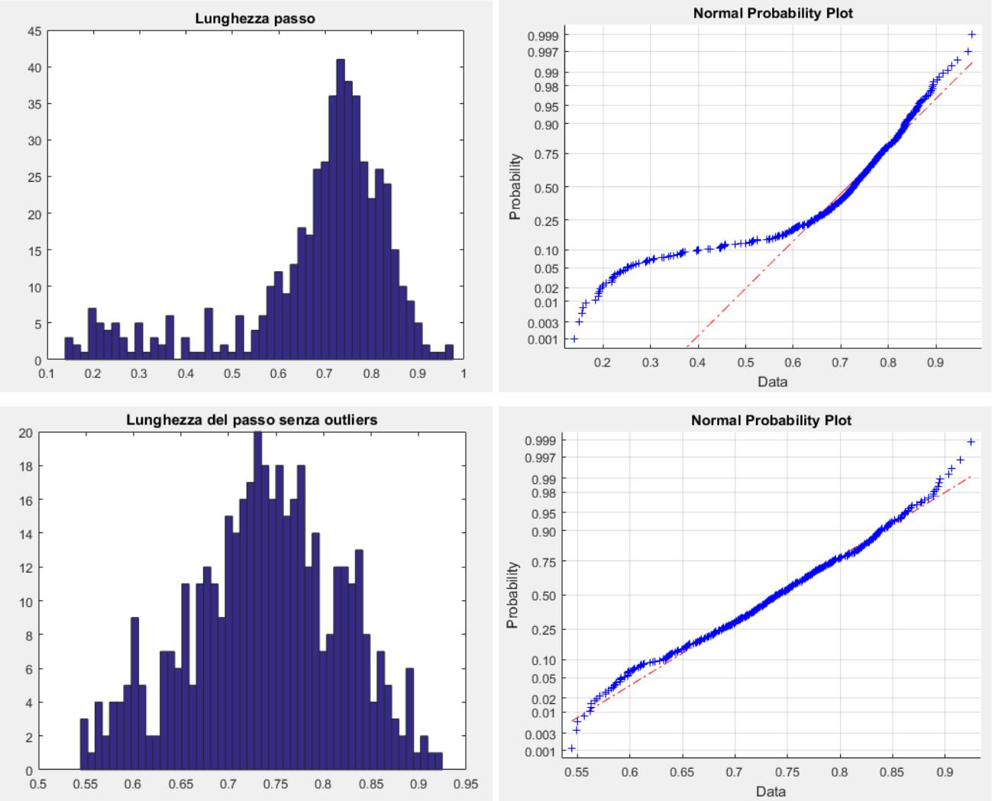

**PAGE | 68**

* **Step Angle**

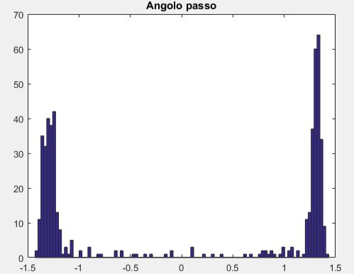

* **θ <0**

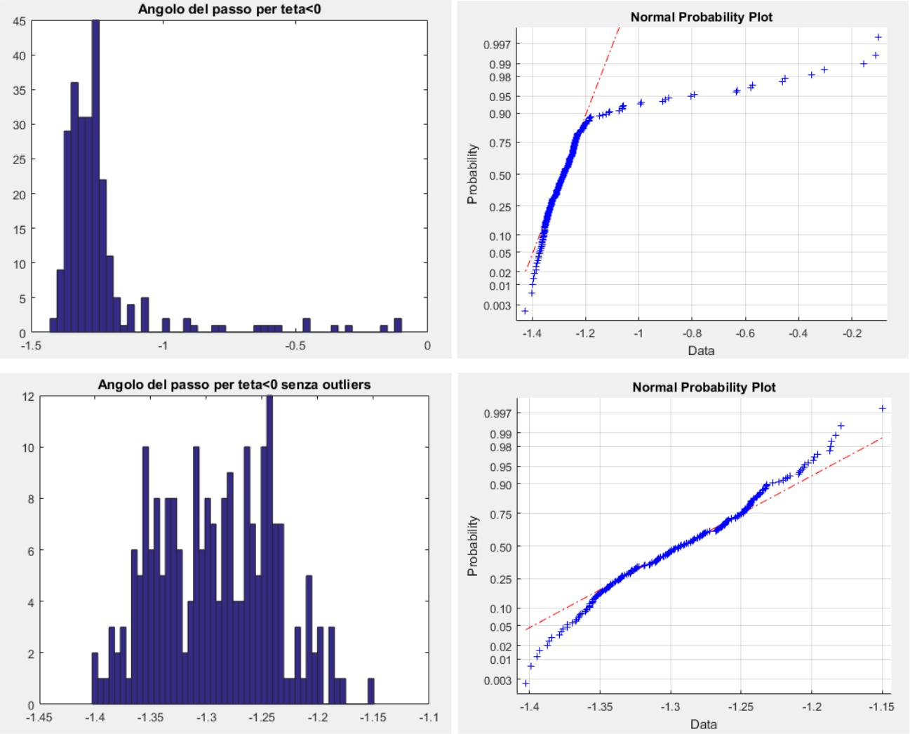

**PAGE | 69**

* **θ> 0**

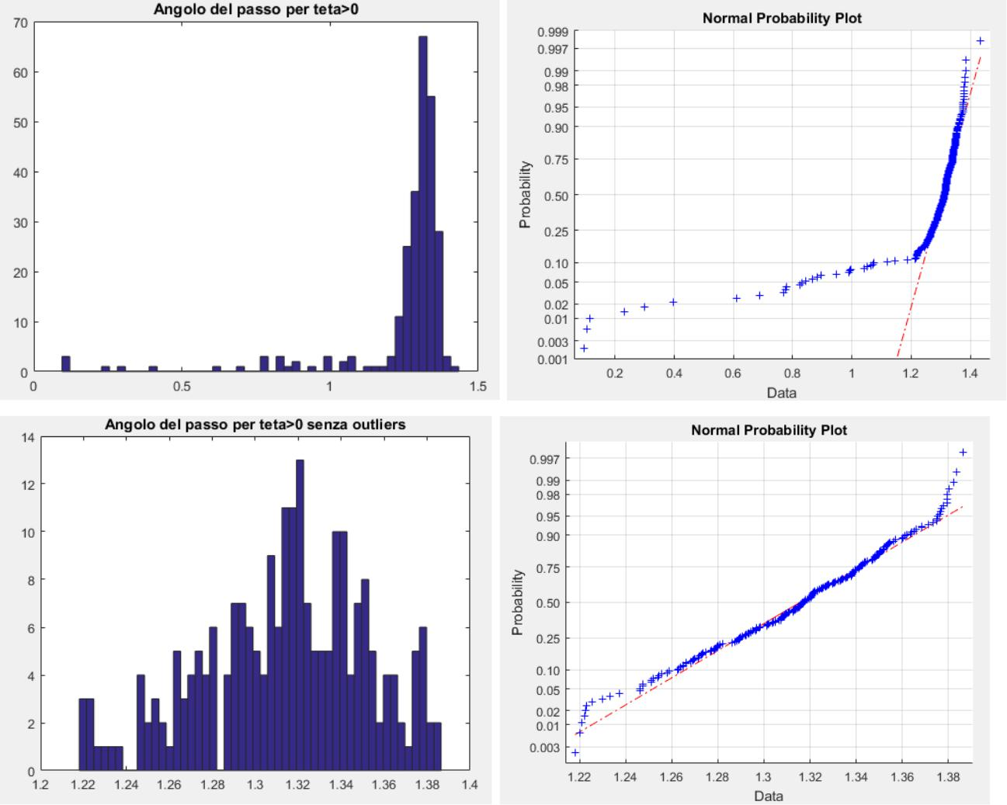

* **step Force**

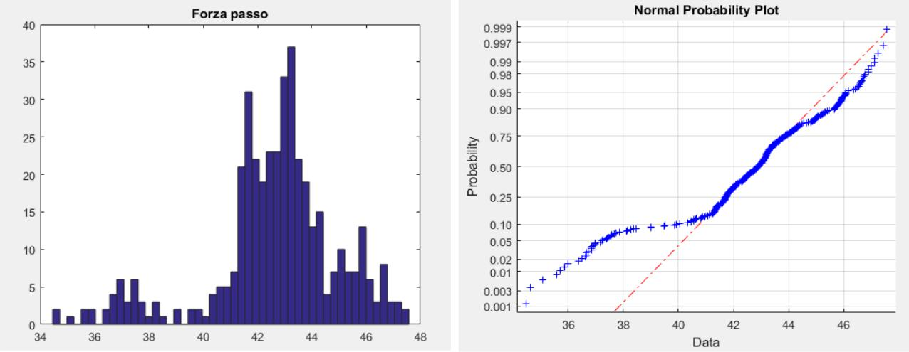

**PAGE | 70**

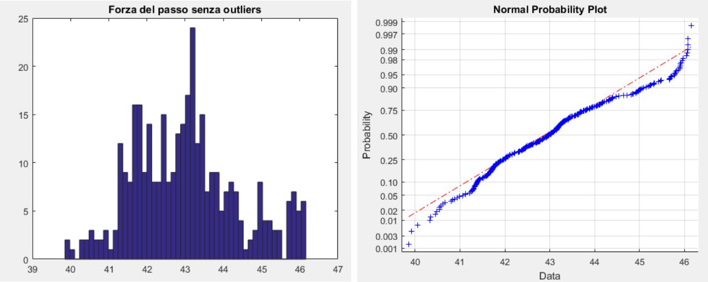

* **Time (step duration)**

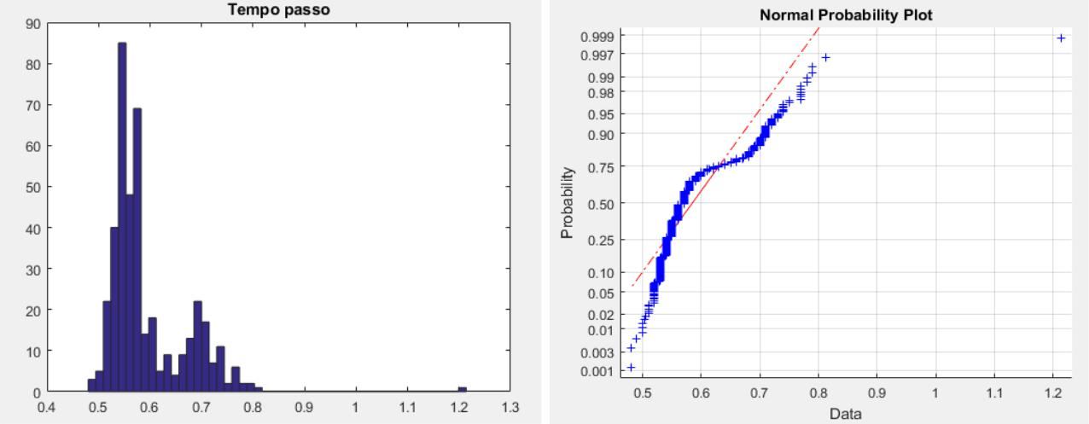

**Data acquisition 2 of person A**

* **stride length**

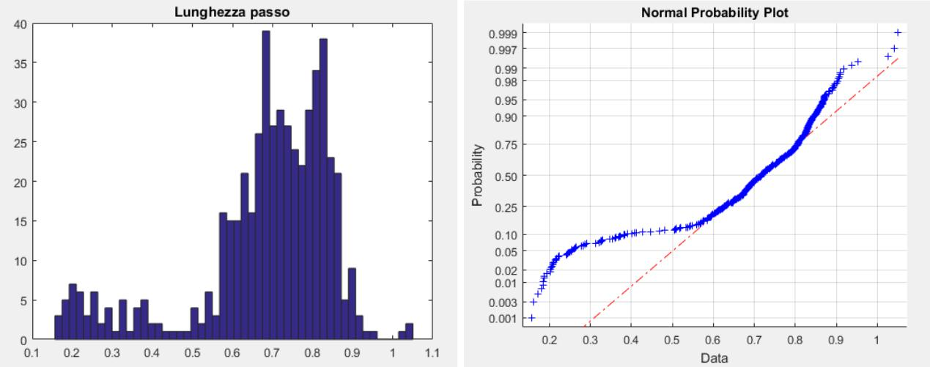

**PAGE | 71**

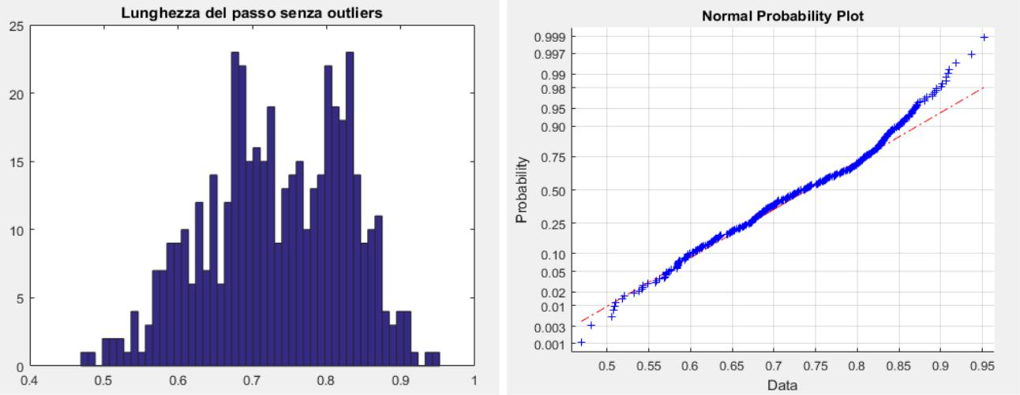

* **Step Angle**

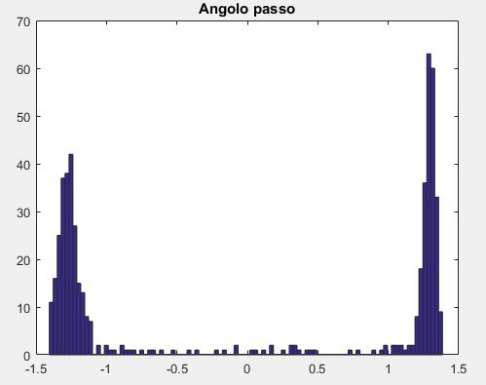

* **θ <0**

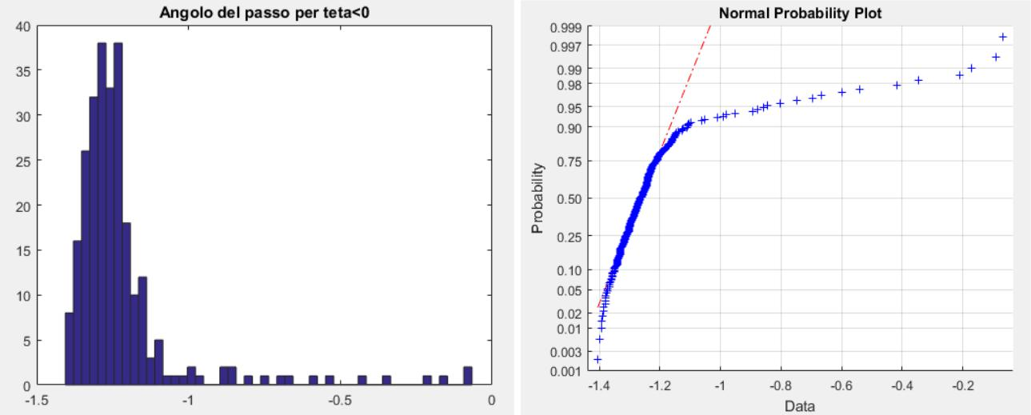

**PAGE | 72**

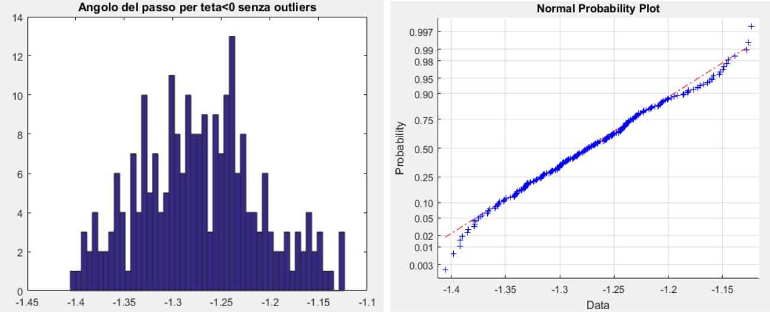

* **θ> 0**

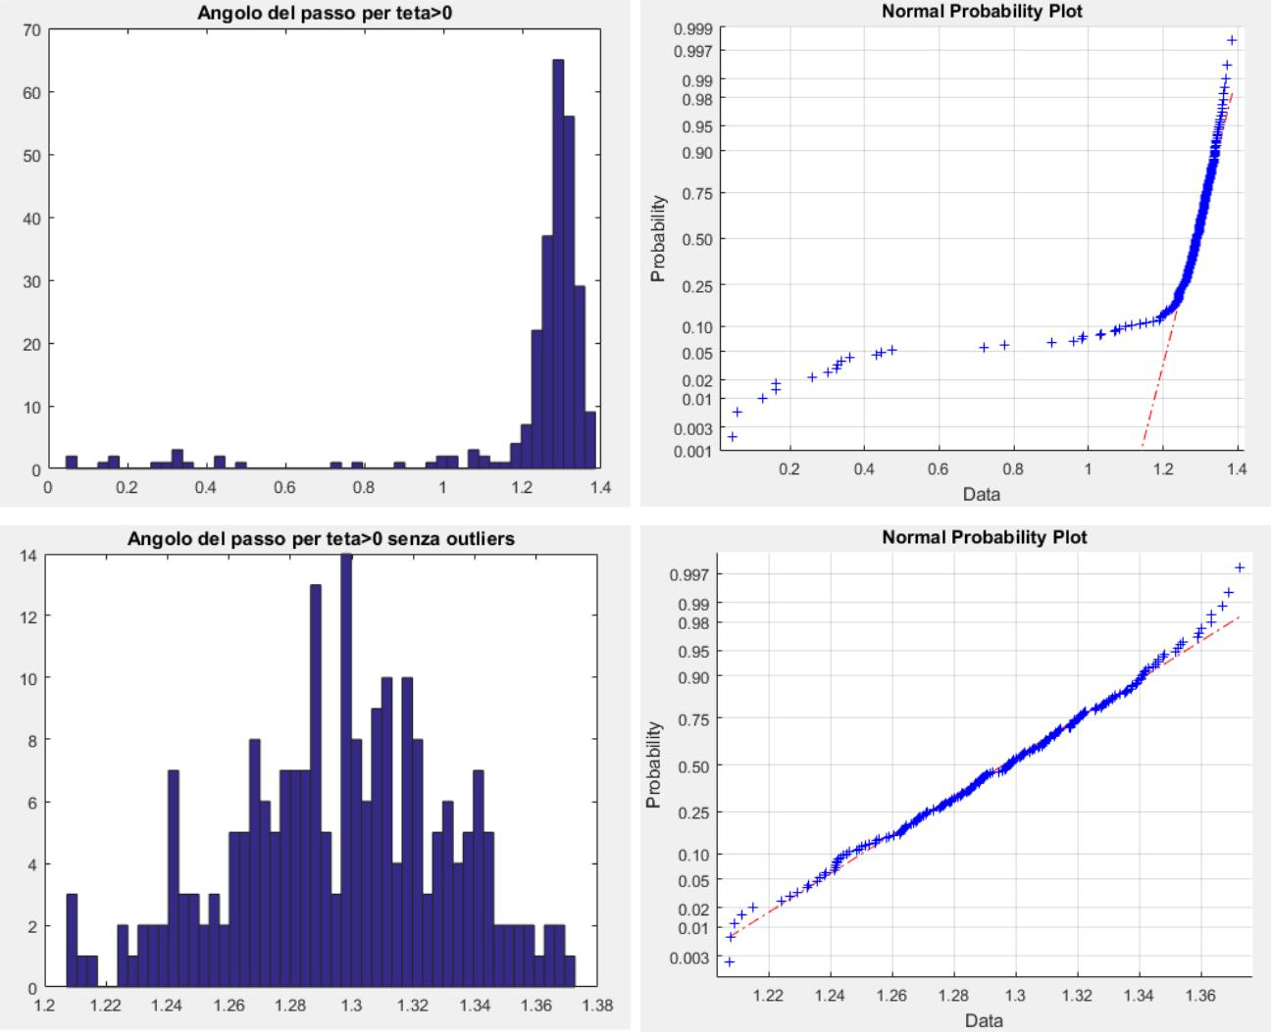

**PAGE | 73**

* **step Force**

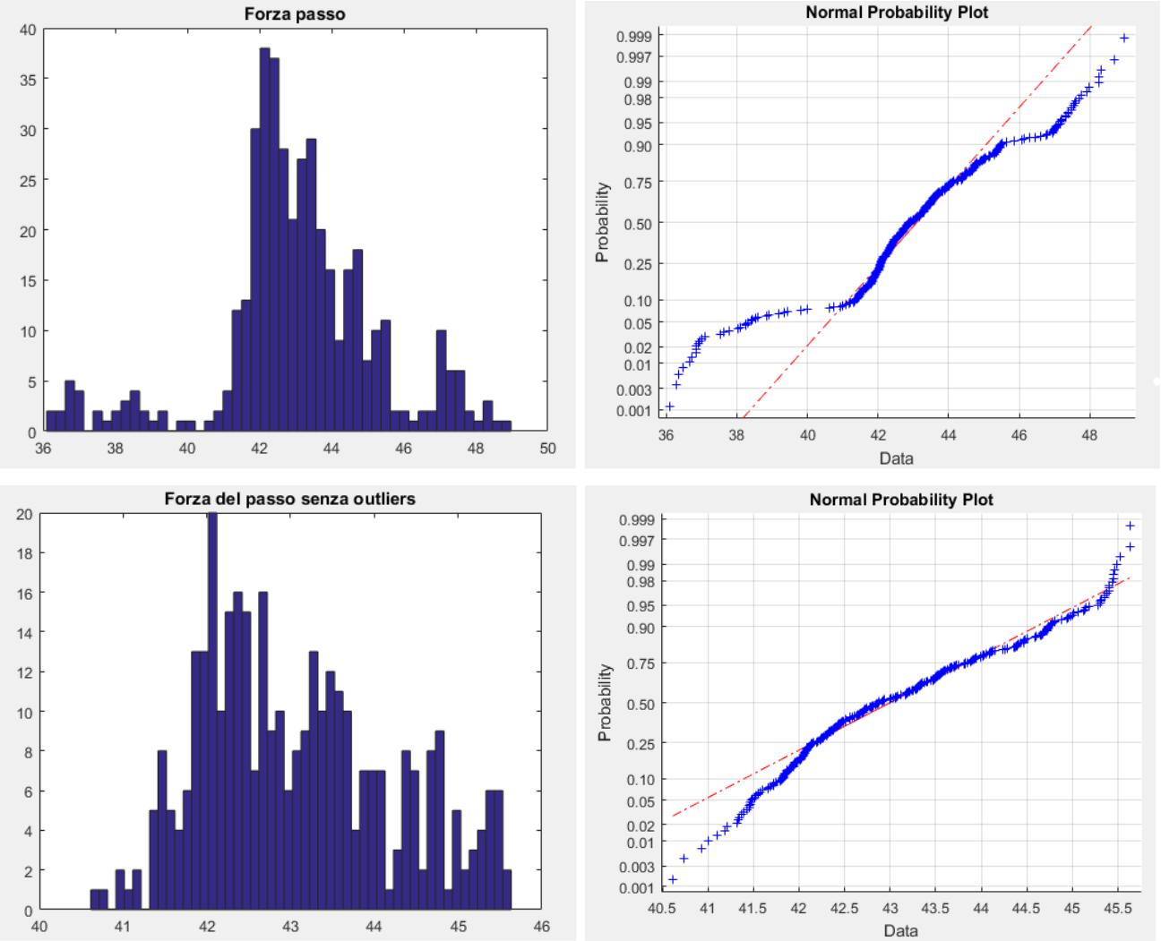

* **Time (step duration)**

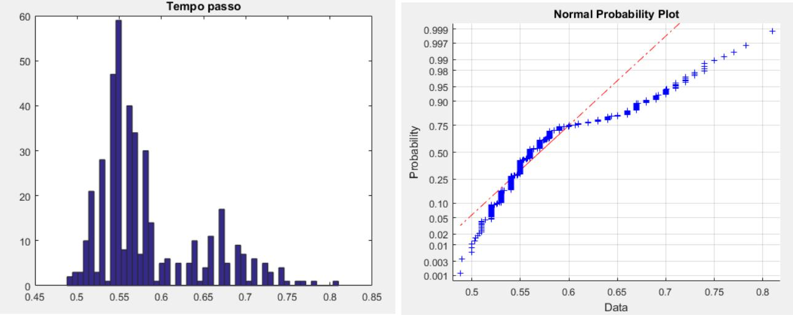

**PAGE | 74**

**Acquisition data subject B 1**

* **stride length**

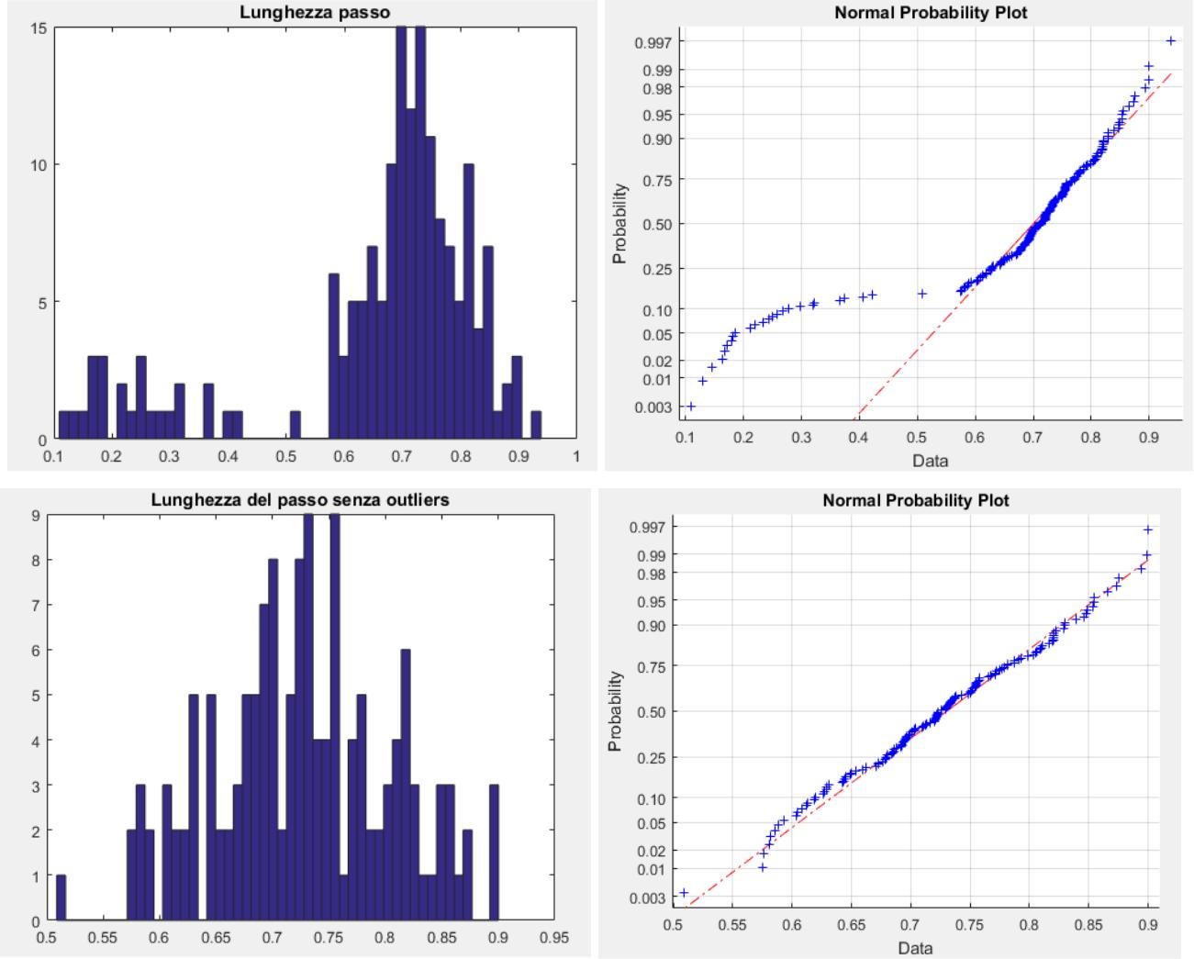

* **Step Angle**

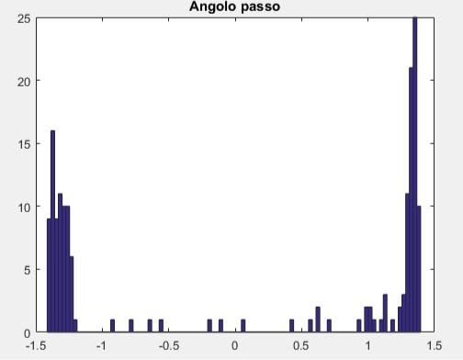

**PAGE | 75**

* **θ <0**

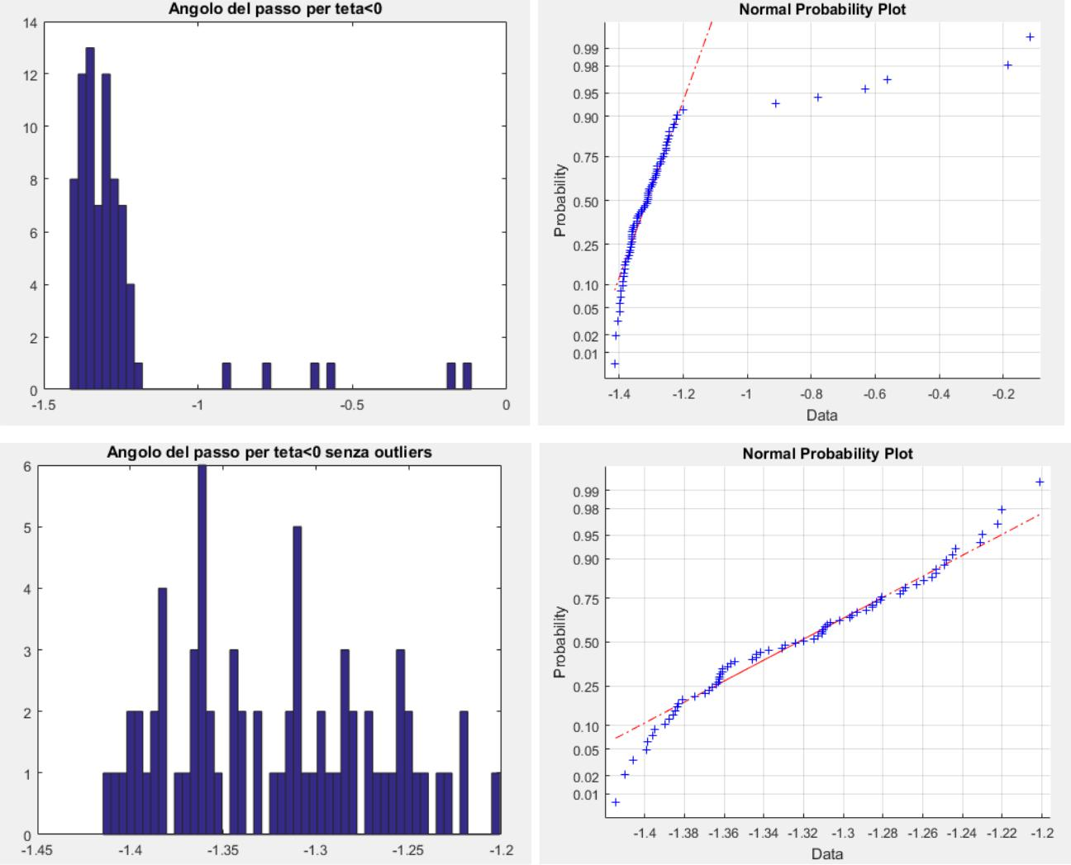

* **θ> 0**

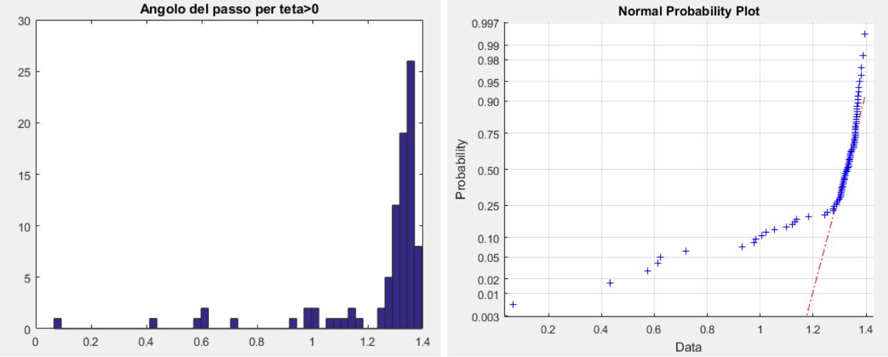

**PAGE | 76**

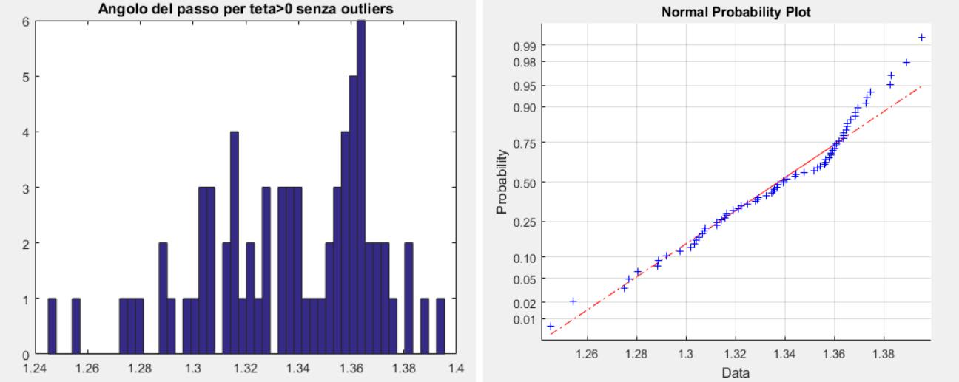

* **step Force**

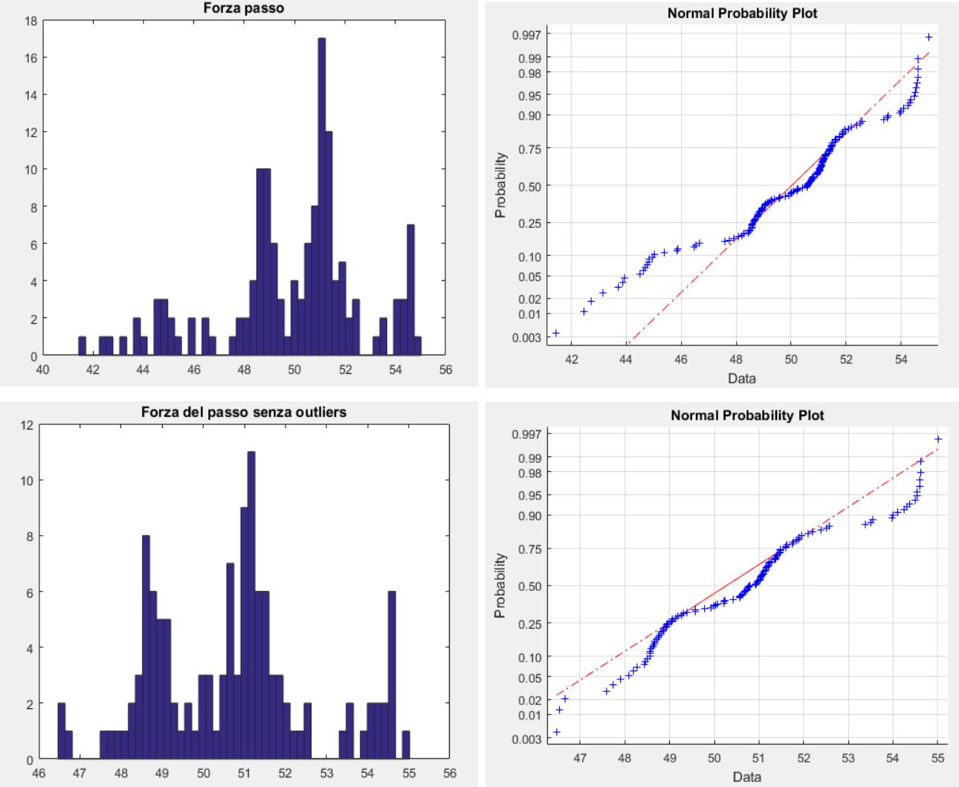

**PAGE | 77**

* **Time (step duration)**

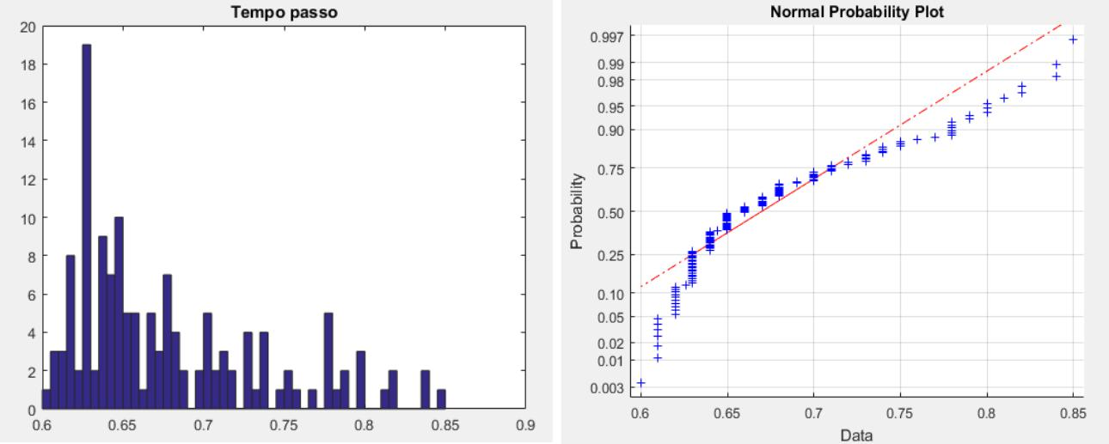

**Acquisition data subject B 2**

* **stride length**

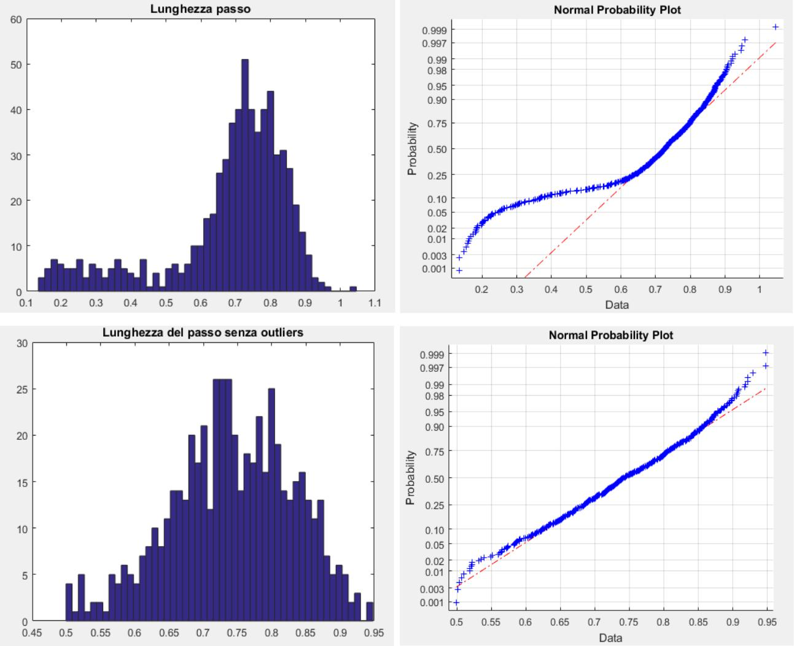

**PAGE | 78**

* **Step Angle**

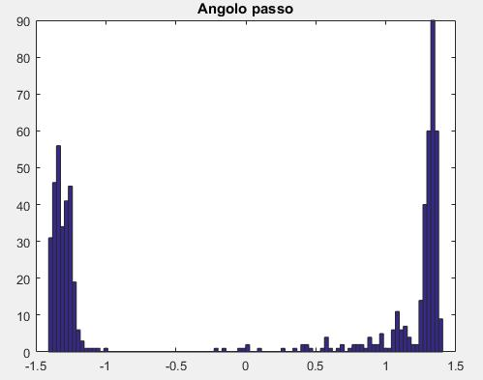

* **θ <0**

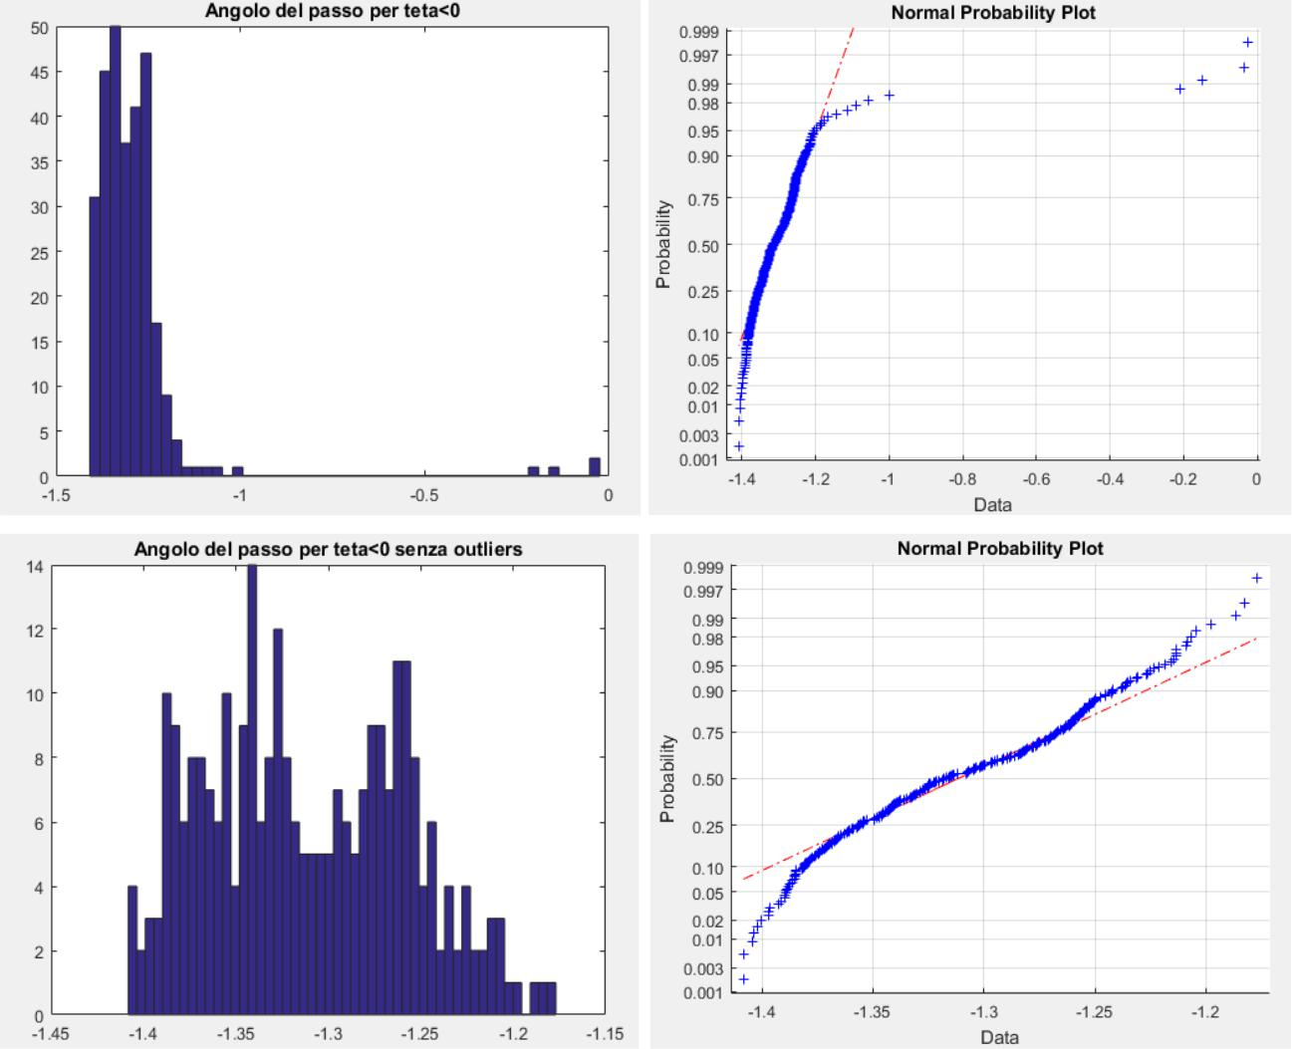

**PAGE | 79**

* **θ> 0**

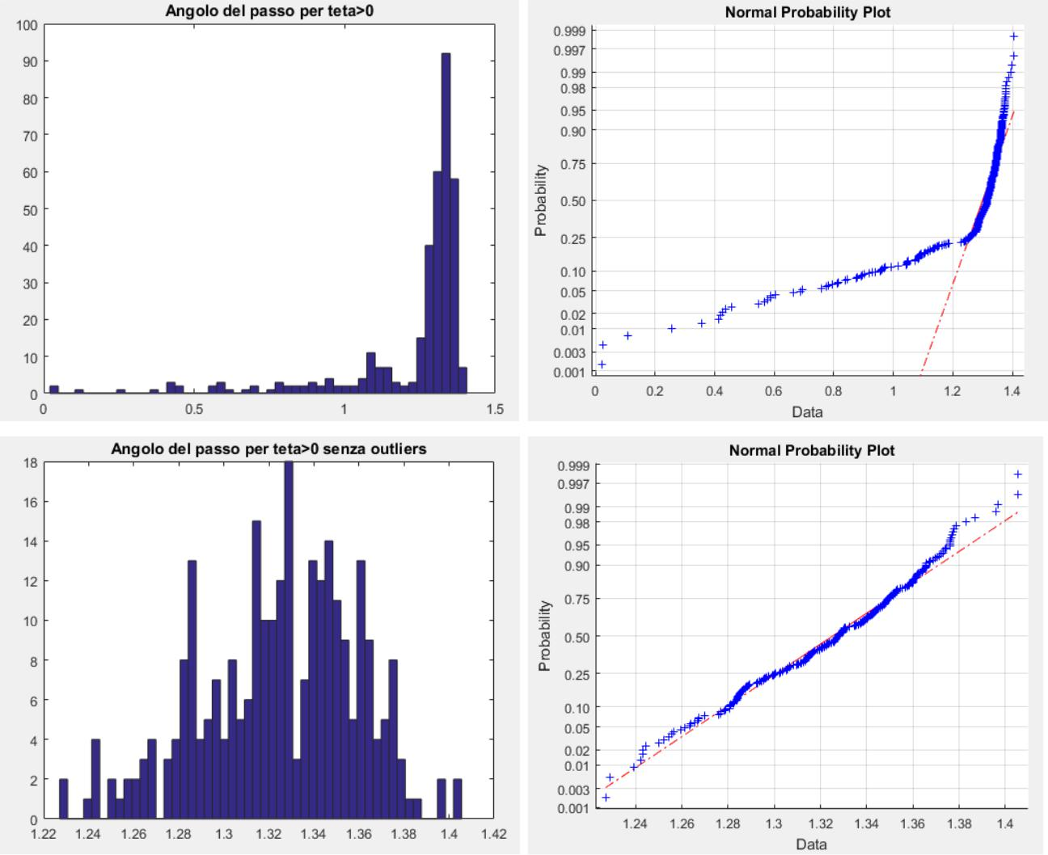

* **step Force**

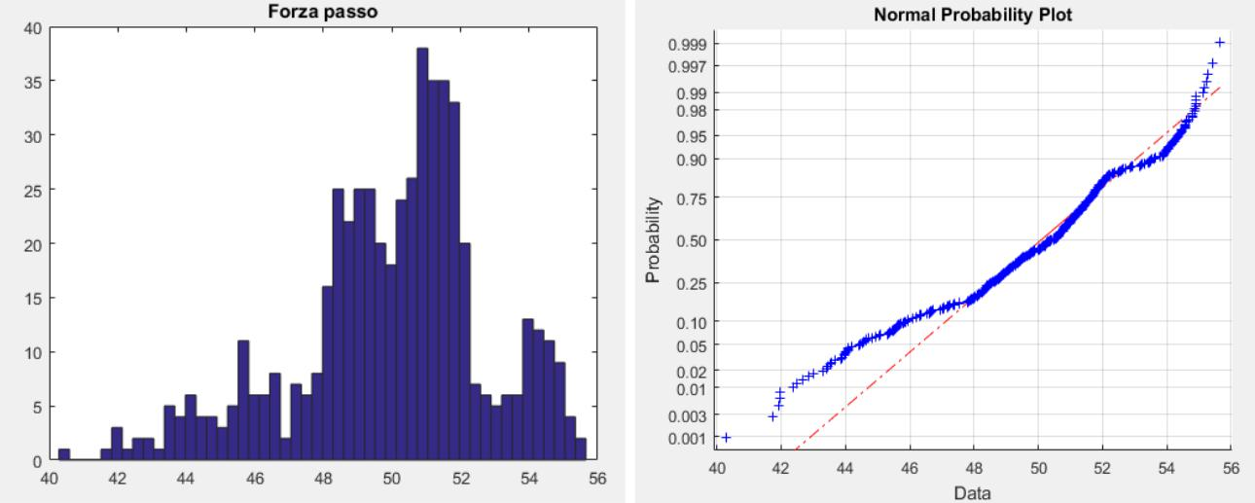

**PAGE | 80**

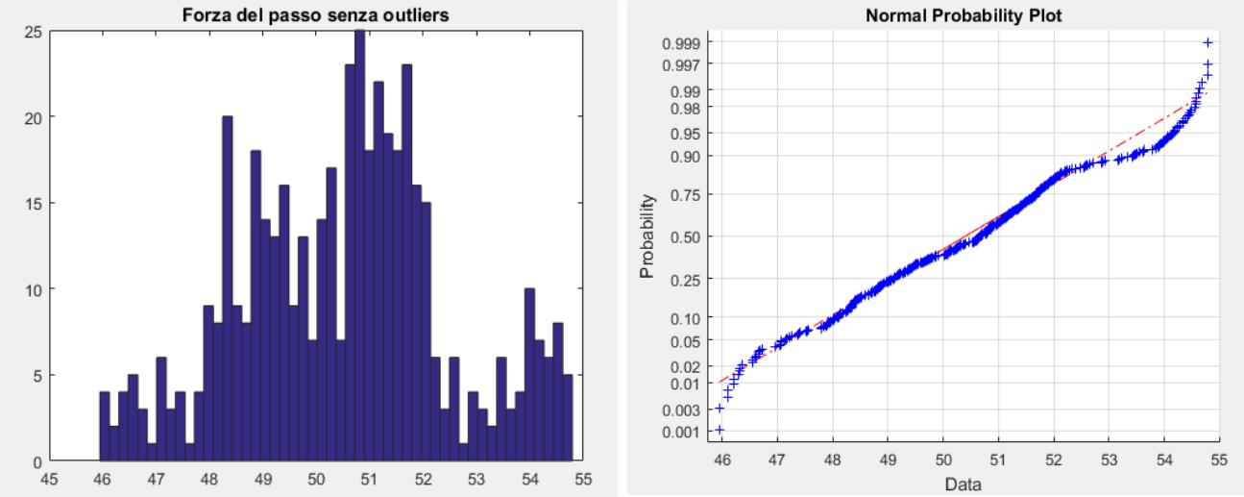

* **Time (step duration)**

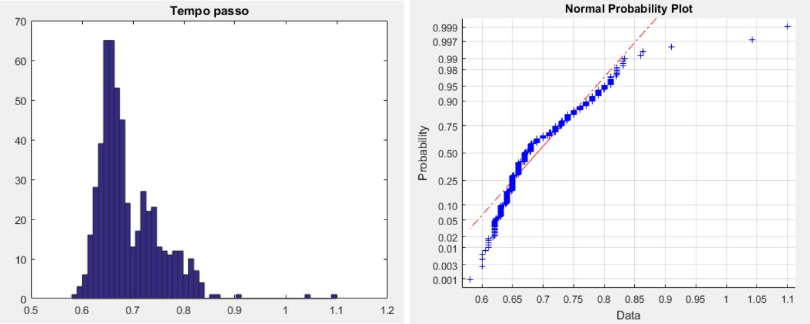

**PAGE | 81**

**Acquisition data subject 1 C**

* **stride length**

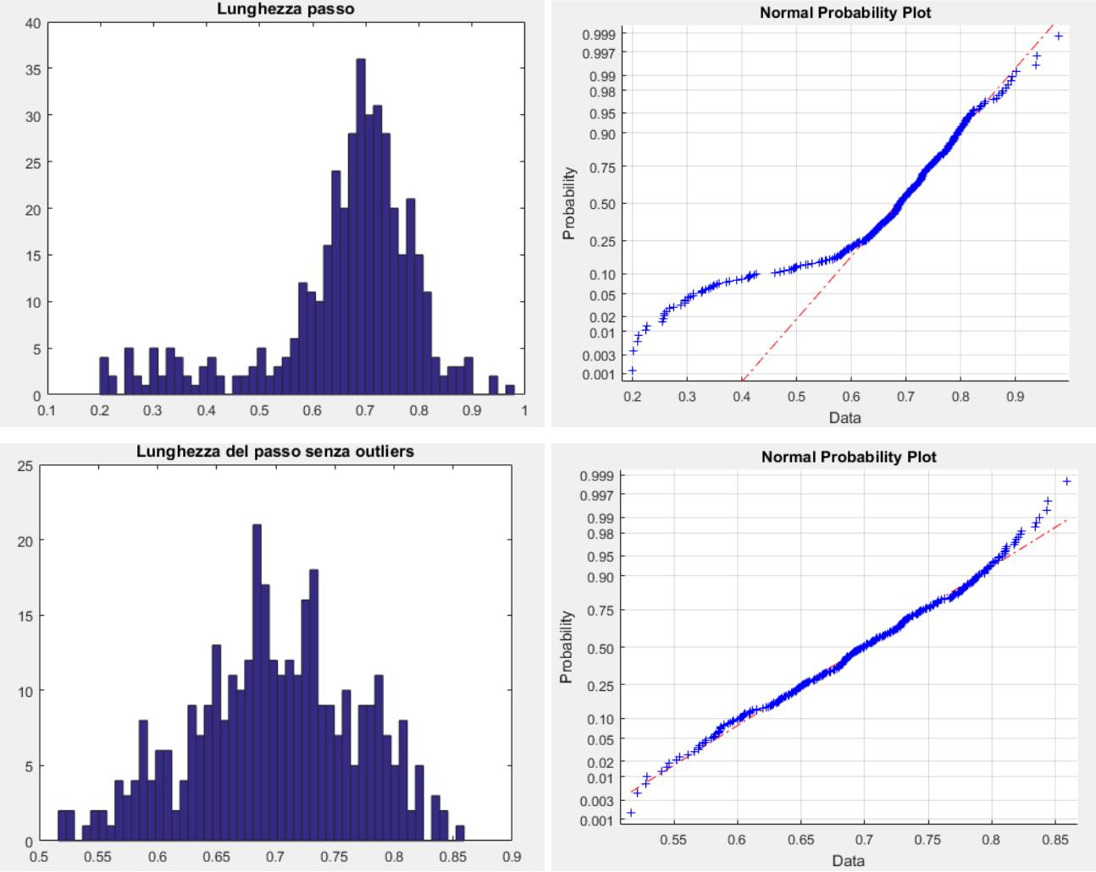

* **Step Angle**

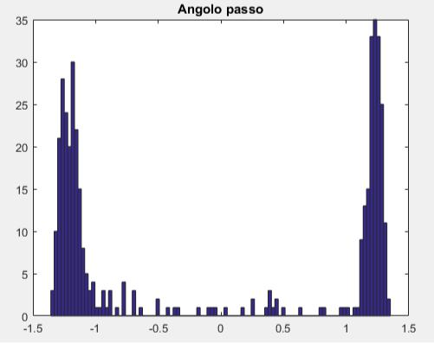

**PAGE | 82**

* **θ <0**

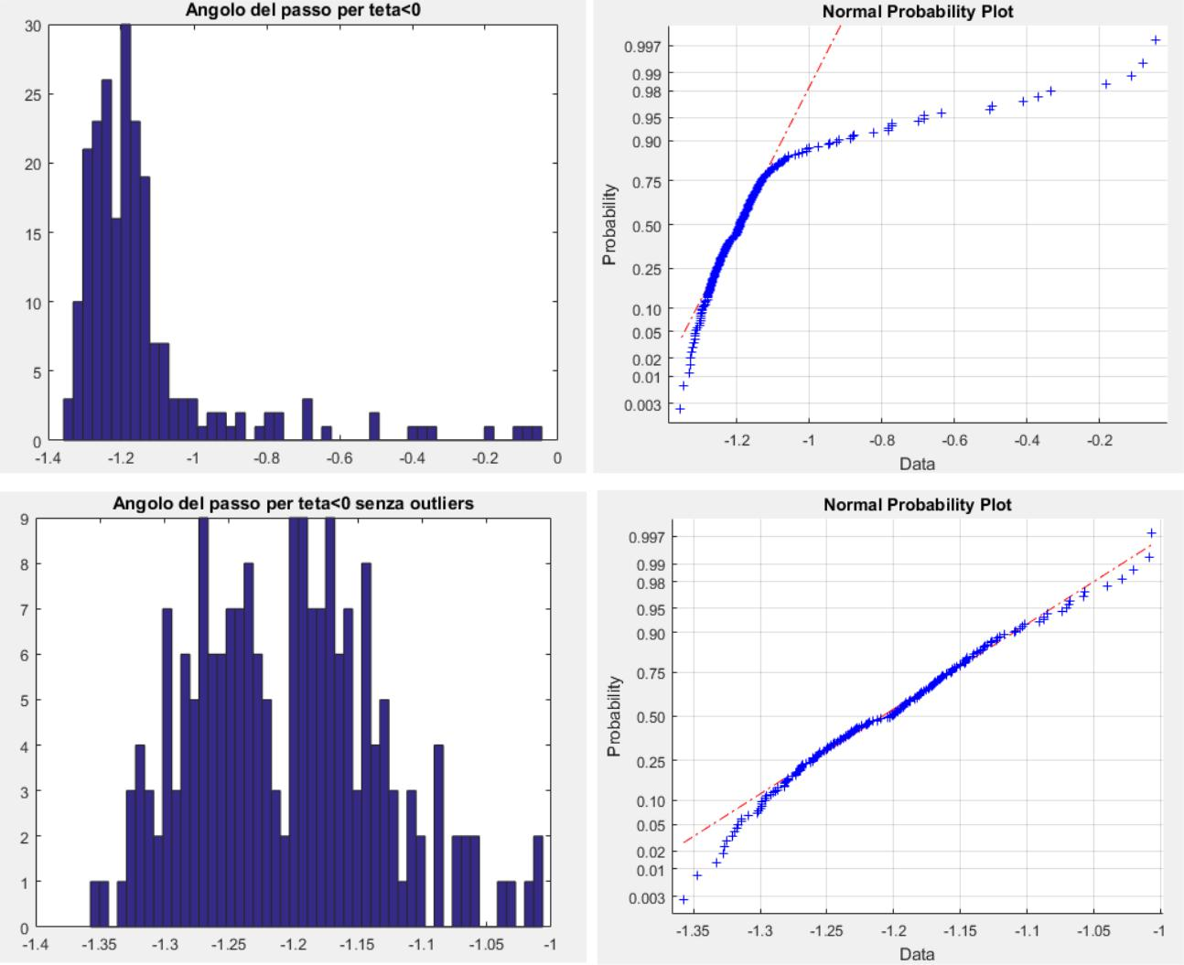

* **θ> 0**

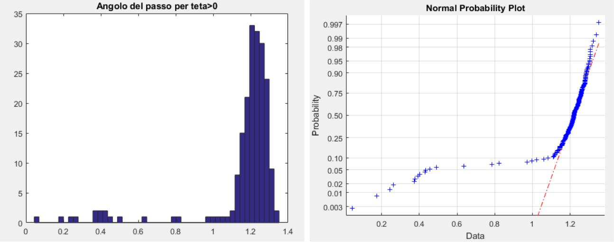

**PAGE | 83**

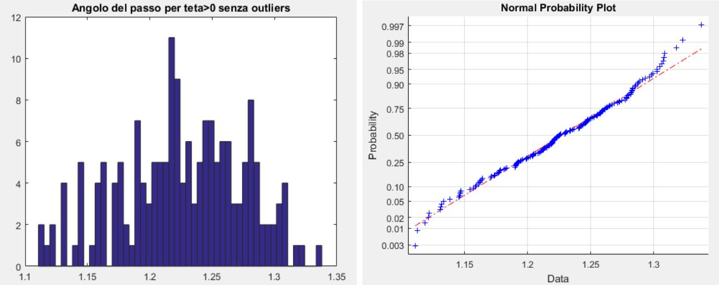

* **step Force**

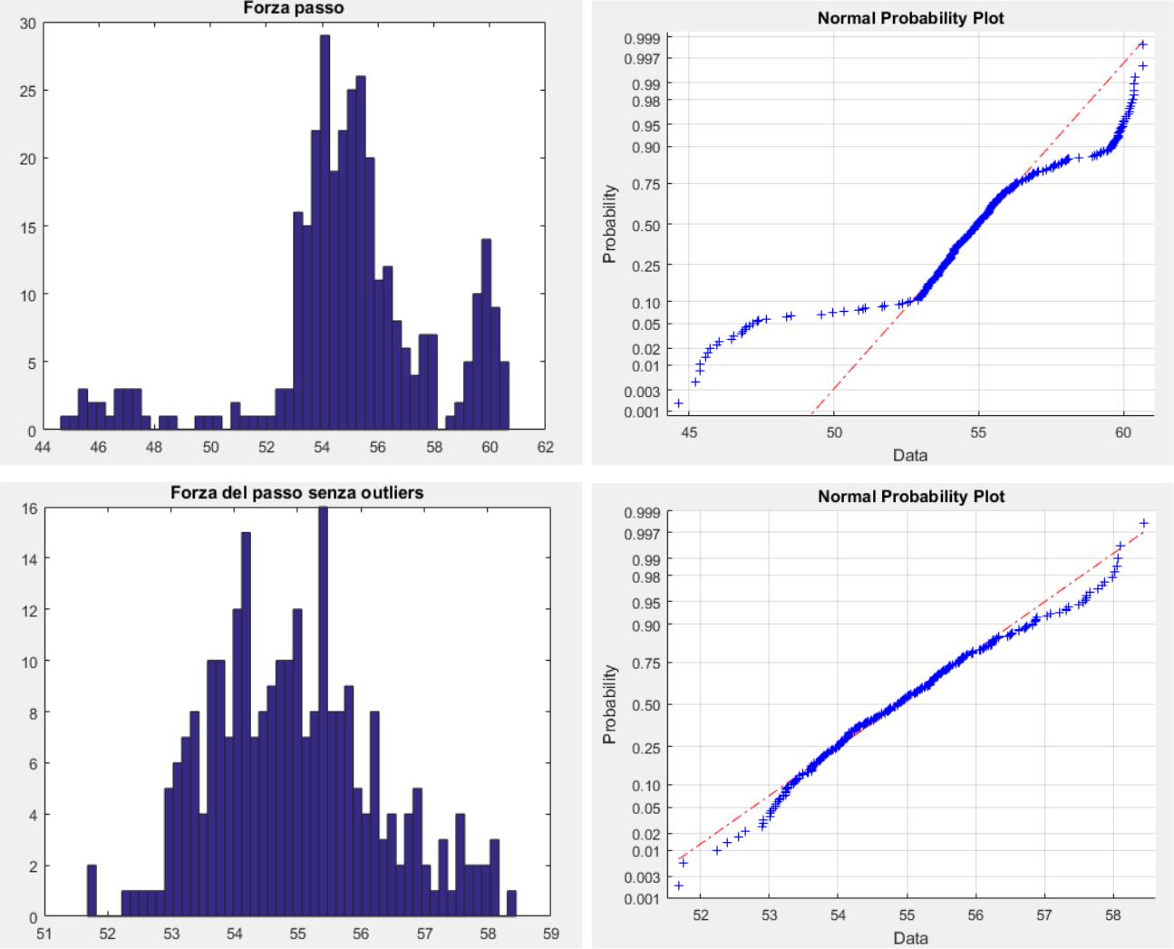

**PAGE | 84**

* **Time (step duration)**

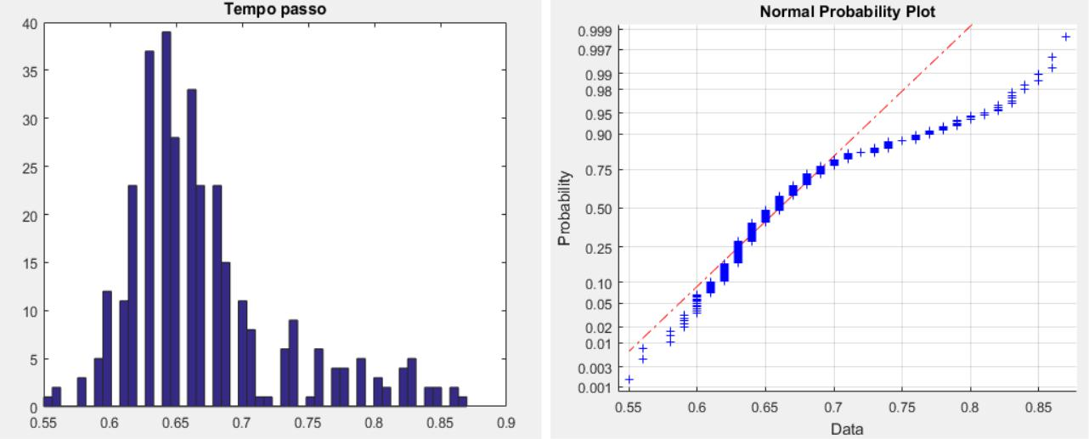

**Acquisition data subject 2 C**

* **stride length**

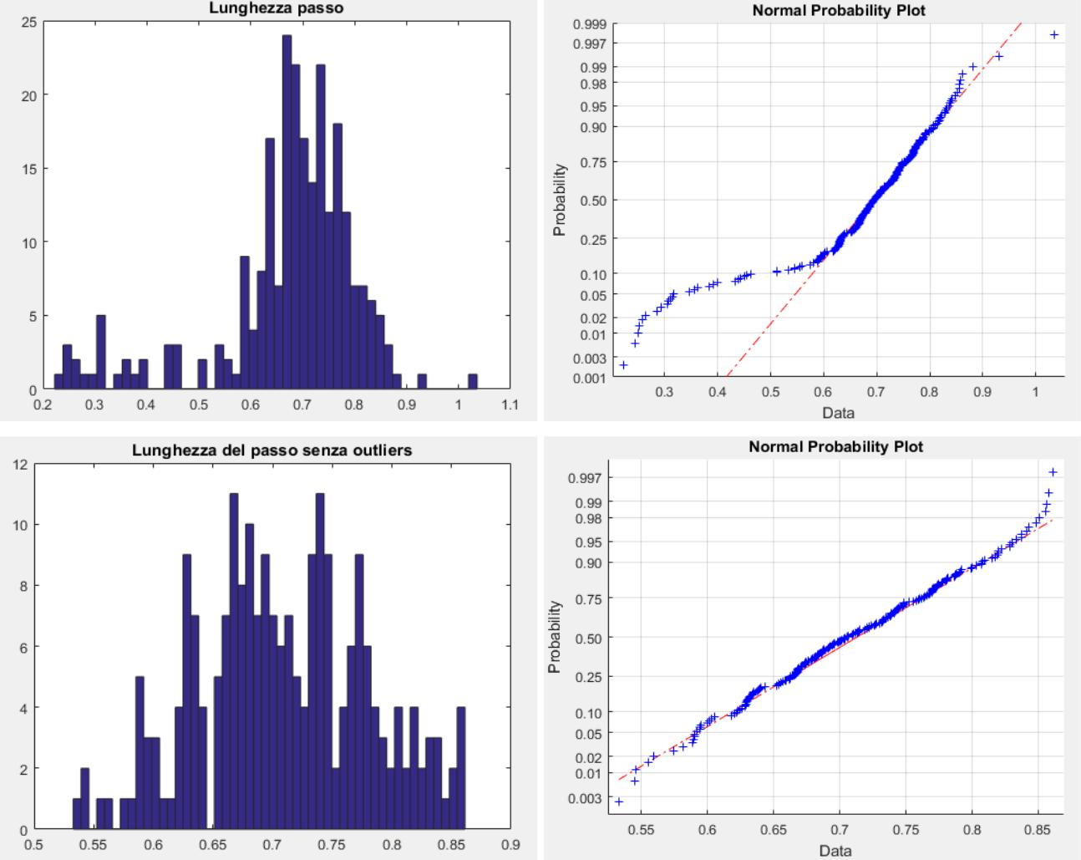

**PAGE | 85**

* **Step Angle**

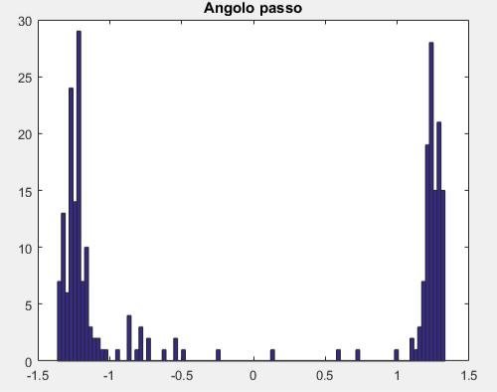

* **θ <0**

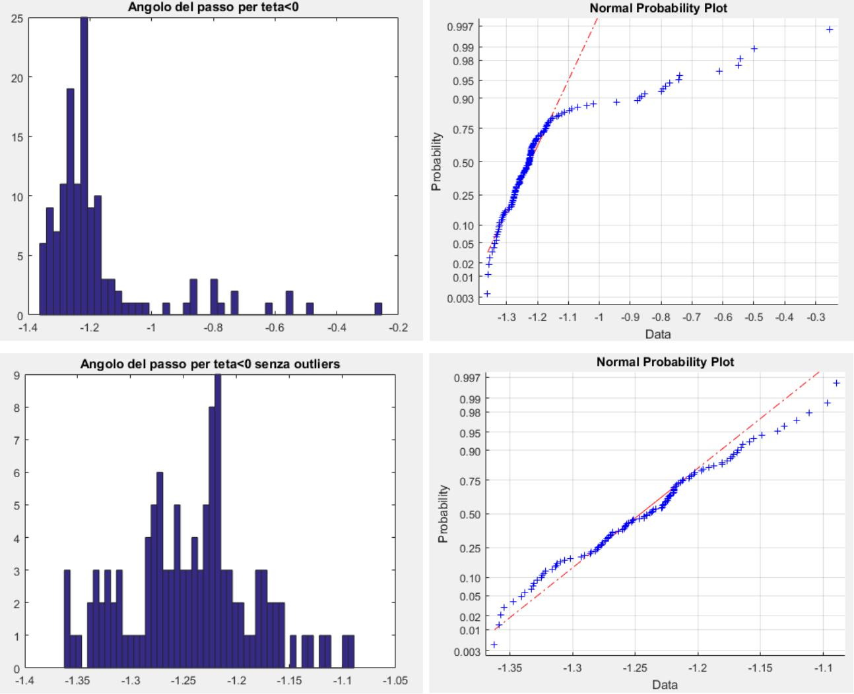

**PAGE | 86**

* **θ> 0**

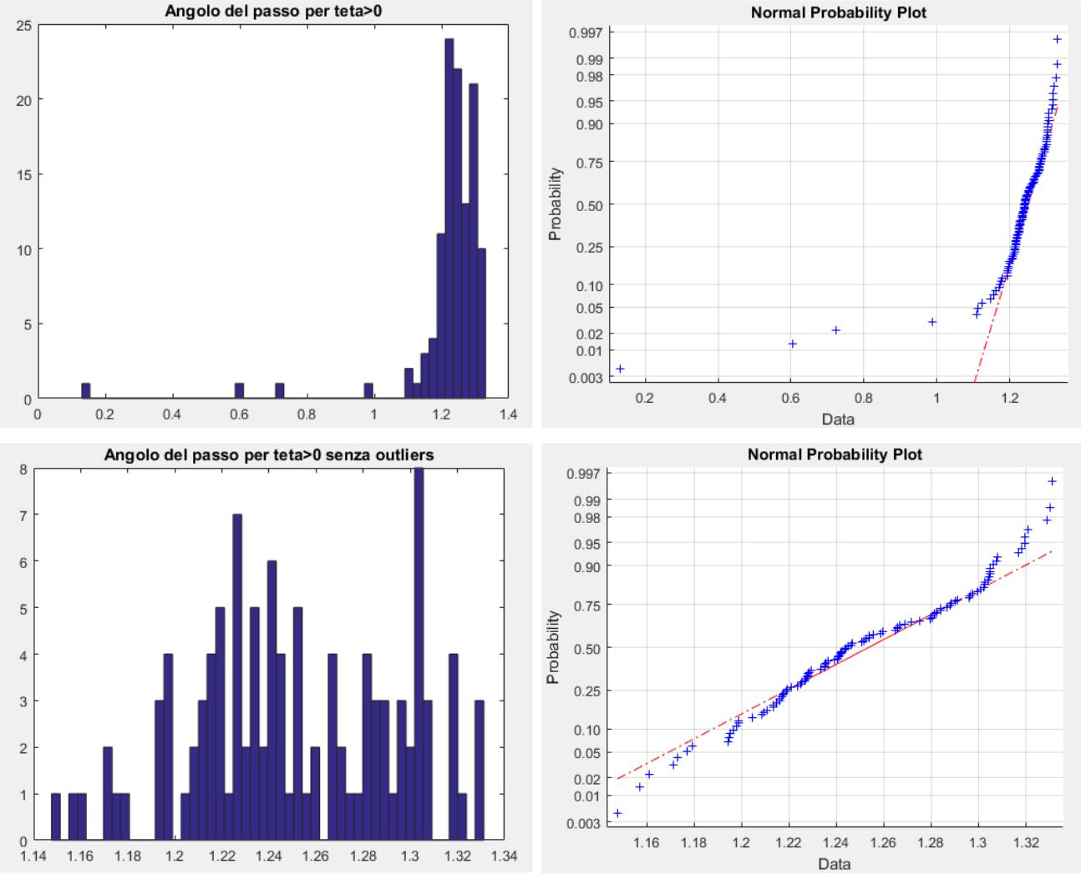

* **step Force**

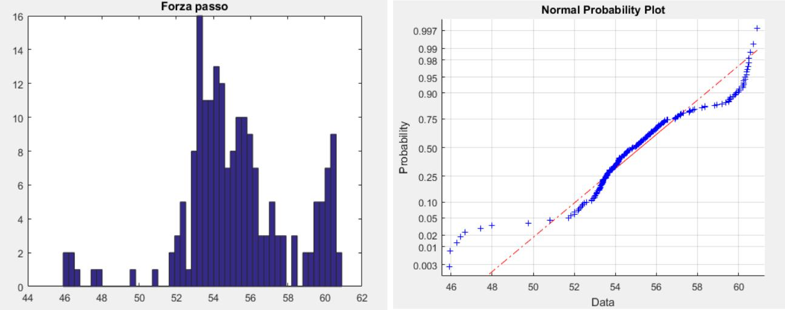

**PAGE | 87**

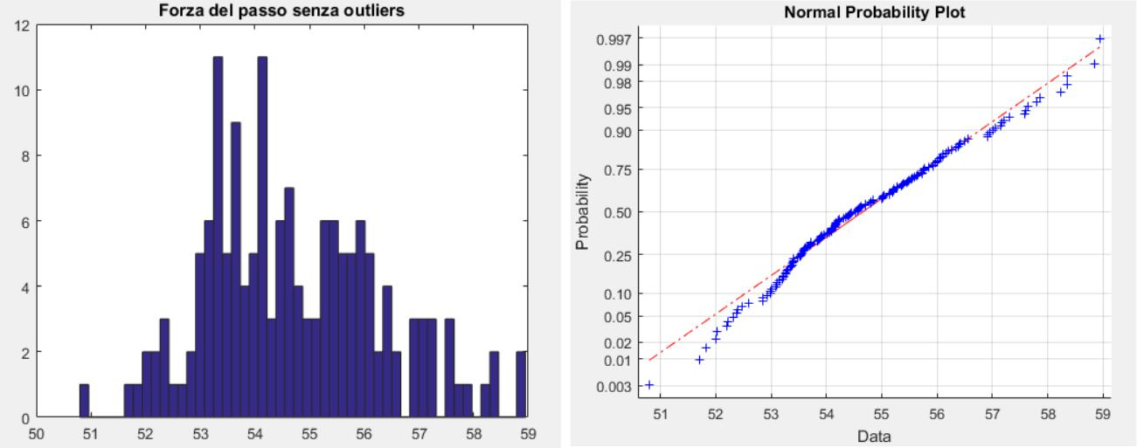

* **Time (step duration)**

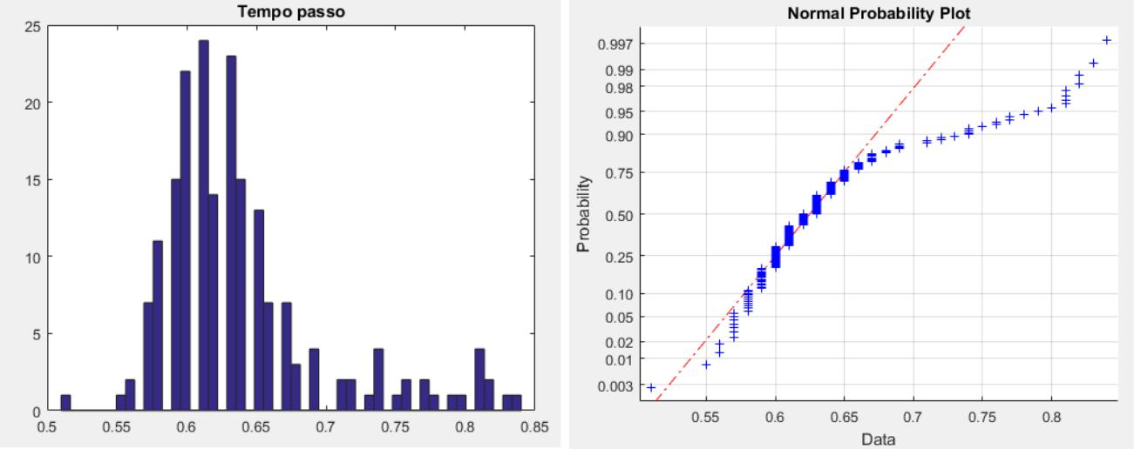

**8.2 APPENDIX 2**

**1) Matrices A subject correlation Acquisition 1**

***step Time*** ***step*** ***Length*** ***step***

***Force*** ***step*** ***angle***

***step Time***

***step Force***

***stride length***

|  |  |  |  |
| --- | --- | --- | --- |
| **1.0000** | **- 0.4559** | **- 0.2841** | **0.0162** |
|  |  |  |  |
| **- 0.4559** | **1.0000** | **0.0910** | **0.0105** |
|  |  |  |  |
| **- 0.2841** | **0.0910** | **1.0000** | **0.1697** |
|  |  |  |  |

**PAGE | 88**

|  |  |  |  |  |
| --- | --- | --- | --- | --- |
| ***step angle*** | **0.0162** | **0.0105** | **0.1697** | **1.0000** |
|  |  |  |  |  |

**Capture 2**

***step Time*** ***step*** ***Length*** ***step***

***Force*** ***step*** ***angle***

***step Time***

***step Force***

***stride length step angle***

|  |  |  |  |
| --- | --- | --- | --- |
| **1.0000** | **- 0.4304** | **- 0.2235** | **0.0718** |
|  |  |  |  |
| **- 0.4304** | **1.0000** | **0.2811** | **- 0.2697** |
|  |  |  |  |
| **- 0.2235** | **0.2811** | **1.0000** | **0.1562** |
|  |  |  |  |
| **0.0718** | **- 0.2697** | **0.1562** | **1.0000** |

**2) Matrices subject correlation B Acquisition 1**

***step Time*** ***step*** ***Length*** ***step***

***Force*** ***step*** ***angle***

***step Time***

***step Force***

***stride length step angle***

**Capture 2**

|  |  |  |  |
| --- | --- | --- | --- |
| **1.0000** | **- 0.2505** | **- 0.2349** | **0.1854** |
|  |  |  |  |
| **- 0.2505** | **1.0000** | **- 0.0449** | **0.3925** |
|  |  |  |  |
| **- 0.2349** | **- 0.0449** | **1.0000** | **0.0161** |
|  |  |  |  |
| **0.1854** | **0.3925** | **0.0161** | **1.0000** |

***step Time*** ***step*** ***Length*** ***step***

***Force*** ***step*** ***angle***

***step Time***

***step Force***

***stride length***

|  |  |  |  |
| --- | --- | --- | --- |
| **1.0000** | **- 0.2351** | **- 0.2385** | **0.1062** |
|  |  |  |  |
| **- 0.2351** | **1.0000** | **0.0938** | **0.3779** |
|  |  |  |  |
| **- 0.2385** | **0.0938** | **1.0000** | **0.0572** |
|  |  |  |  |

**PAGE | 89**

|  |  |  |  |  |
| --- | --- | --- | --- | --- |
| ***step angle*** | **0.1062** | **0.3779** | **0.0572** | **1.0000** |
|  |  |  |  |  |

**3) Matrices subject correlation C Acquisition 1**

***step Time*** ***step*** ***Length*** ***step***

***Force*** ***step*** ***angle***

***step Time***

***step Force***

***stride length step angle***

**Capture 2**

|  |  |  |  |
| --- | --- | --- | --- |
| **1.0000** | **- 0.3478** | **- 0.0509** | **- 0.1179** |
|  |  |  |  |
| **- 0.3478** | **1.0000** | **- 0.1492** | **0.1694** |
|  |  |  |  |
| **- 0.0509** | **- 0.1492** | **1.0000** | **0.0287** |
|  |  |  |  |
| **- 0.1179** | **0.1694** | **0.0287** | **1.0000** |

***step Time*** ***step*** ***Length*** ***step***

***Force*** ***step*** ***angle***

***step Time***

***step Force***

***stride length step angle***

|  |  |  |  |
| --- | --- | --- | --- |
| **1.0000** | **- 0.3039** | **- 0.0180** | **- 0.1059** |
|  |  |  |  |
| **- 0.3039** | **1.0000** | **- 0.0695** | **0.0908** |
|  |  |  |  |
| **- 0.0180** | **- 0.0695** | **1.0000** | **0.1217** |
|  |  |  |  |
| **- 0.1059** | **0.0908** | **0.1217** | **1.0000** |

**PAGE | 90**

**Bibliography**

1. **CLCD MRM Antinori, pedestrian walkways steel, Palermo: Dario Flaccovio Publisher, 2017.**
2. **JPRW Clough, Dynamics of Structures, New York: McGraw-Hill, 1993.**
3. **DC Giancoli, Physics, Milan: Casa Editrice Ambrosiana, 2009.**
4. **AFRCCSY Deger, "Dynamic modeling and testing of a cable stayed pedestrian bridge,"**

**in *Proceedings of the 14th International Modal Analysis Conference,* vol. Vol. 1, Dearborne, Michigan, USA, 1996, p. 211-217.**

**[5] CKM,. TMHT Ventura, "Dynamic analysis of a pedestrian walkway," in *Proceedings of***

***the international modal analysis conference (imac xx)* vol. Vol.1, Los Angeles, California: University of British Columbia,2002, pp. 114-119.**

1. **JMMI Friswell Finite Element Model Updating in Structural Dynamics, Dordrecht: Kluwer Academic Publishers, 1995.**
2. **MJHPWA Pavic, "Updating of the analytical models of two footbridges based on modal**

**testing of full-scale structures, "in *Proceedings of the International Conference on Noise and Vibration Engineering (ISMA***

* 1. **Leuven, Belgium, 1998, p. 1111-1118.**

1. **P.-QXJMW Brownjohn, "Dynamic assessment of curved cable-stayed bridge by model updating, "in *Journal of Structural Engineering,* 2000, p. 252-260.**
2. **Ewins DJ, Modal Testing: Theory, Practice and Application, Baldock, England: Research Studies Press, 2000.**
3. **J. Przemieniecki, Theory of Matrix Structural Analysis, New York: Dover Publications, 1968.**
4. **MG Gardner-Morse, Modal Analysis of a Cable-Stayed Pedestrian Bridge, The Faculty of the Graduate College, The University of Vermont, 1990.**
5. **DHMG Gardner-Morse, "Modal identification of cable-stayed pedestrian bridge," *Journal* *of Structural Engineering,* vol. 119, n. 11, pp. 3384-3404, 1993.**
6. **OHMZMA Khalifa, "Analysis and design methodology for an FRP cable-stayed pedestrian bridge, " *Composites B,* vol. 27, pp. 307-317, 1996.**
7. **R. Pimentel, Vibrational Performance of Pedestrian Bridges Due to Human-Induced Loads, Sheffield, UK: University of Sheffield, 1997.**

**PAGE | 91**

**[15] THKST Obata, "Study on dynamic response characteristics and identification of walking**

**Force on pedestrian bridges, "in *Proceedings of the Seventh East Asia-Pacific Conference on Structural Engineering and* *Construction (EASEC-7),* Japan, in 1999.**

1. **G. Tilly, "Damping of highway bridges: a review," in *Proceedings of the DOE and DOT TRRL* *Symposium on Dynamic Behavior of Bridges,* Crowthorne, UK, 1977, p. 1-9.**
2. **A.Pavic, Vibration serviceability of Long-Span Cast In Situ Concrete Floors, PhD Thesis, Department of Civil and Structural Engineering, University of Sheffield, Sheffield, UK ,, 1999.**
3. **T. Wyatt, "Mechanisms of damping," in *Proceedings of the Symposium on DOE and DOT TRRL* *Dynamic Behavior of Bridges,* Crowthorne, UK, 1977, p. 10-19.**
4. **VTRHJ a. TF lnman, Human Walking, Philadelphia, PA: Williams & Wilkins, 1981.**
5. **M. Perc, The Dynamics of Human Gait, Eur. J. Phys., 2005, pp. 525-534.**
6. **CLDBL a. JCO Vaughan, Dynamics of Human Gait, Cape Town, South Africa: Kiboho Publishers, 1992.**
7. **E. Ayyappa, Normal Human Locomotion, Part I: Basic Concepts and Terminology, American Academy of orthotists & Prosthetists, 1997.**
8. **N. Messenger, Moving the Human Machine: Understanding the Mechanical Characteristics of Normal Human Walking, 1994, pp. 352-357.**
9. **MW Whittle, Gait Analysis: An lntroduction, Oxford, UK: Butterworth-Heinemann, 2014.**
10. **JGJG a. AJM Rose, Human Walking, Philadelphia, PA: Lippincott Williams & Wilkins,**

**2006.**

1. **KMSAB Newell, "The Nature of Movement Variability," in *Motor Behavior and Human* *Skill,* Champaign, Human Kinetics Publishers, 1998, pp. 143-160.**
2. **FC Harper, The Mechanics of Walking, Res. Appl. lnd., 1962.**
3. **JDBL a. SJW,. Blanchard, "Design Criteria and Analysis for Dynamic Loading of**

**Footbridges, "in *Symposium on Dynamic Behavior of Bridges at the Transport and Road Research Laboratory,* Crowthorne, Berkshire, UK, Transport and Road Research Laboratory (TRRL), 1977, pp. 9-106.**

1. **SV Ohlsson, Floor Vibration and Human Discomfort, Gothenburg, Sweden: Chalmers University of Technology, 1982.**
2. **KSC, Human lnduced Loading on Staircases, London: University of London, 1998.**

**PAGE | ninety two**

**[31] Wheeler JE, "Pedestrian Footbridges in lnduced Vibrations," in *10th Australian Road***

***Conference Research Board (ARRB)* Sydney, Australia, ARRB Group Limited, 1980, pp. 21-35.**

1. **JE Wheeler, Prediction and Control of Pedestrian Induced Vibration in Footbridges, J. Struct. Div., 1982, pp. 2045-2065.**
2. **OAMHBDPRA Younis, "Dynamic Forces induced by a single pedestrian," *Applied* *Mechanics Reviews,* vol. 69, 2017.**
3. **VPABJMW Racic, "Experimental identification and analytical modeling of human**

**Walking forces: Literature review, " *Journal of Sound and Vibration,* vol. 326, n. 1, pp. 1-49, 2009.**

1. **HAWJDFEJFIHGKGKLGJMO a. NHG Mcrcier, Vibration Problems in Structures: Practical Guidelines, Basel, Switzerland: Birkhauser, 2012.**
2. **M. Yoneda, "A Simplified Method to Evaluate Pedestrian-lnduced of Maximum Response**

**Cable-Supported Pedestrian Bridges, "in *lnternational Conference on the Design and Dynamic Behavior of Footbridges,* Paris, France, 2002, pp. 255-256.**

1. **a. AW Bachmann. H., Vibrations in Structures: lnduced by Man and Machines, Zurich, Switzerland: IABSE, 1987.**
2. **JHPG a. ADE Rainer, "Dynamic Loading and Response of Footbridges," *Canadian* *Journal of Civil Engineering,* vol. 15, n. 1, pp. 66-71, 1988.**
3. **P. Young, Improved Floor Vibration Prediction Methodologies, London: Arup Vibration Seminar on Structural Engineering Vibration, 2001.**
4. **M. YPFC Willford, "Predicting Footfall-lnduced Vibration: Part I," *Proc. Lnst. Civ. Eng.* *Build.,* vol. 160, n. 2, pp. 65-72, 2007.**
5. **K. to. BH Baumann, Dynamic Loads Caused by Humans and Their Effect on Beam Structures, Zurich, Switzerland: Institute of Structural Engineering (IBK), 1988.**
6. **PRL, Vibrational Performance of Pedestrian Bridges Due to Human-Induced Loads,**

**Sheffield, UK: University of Sheffield, 1997.**

1. **MMJHG a. BJF Bocian, "Biomechanically lnspired Modeling of Pedestrian-Induced Vertical Self-Excited Forces, " *J. Bridge Eng.,* vol. 18, n. 12, pp. 1336-1346, 2013.**
2. **CJ. BJMW Middleton, "Response of High Frequency Floor: A Literature Review," *Eng.* *Struct.,* vol. 32, n. 2, pp. 337-352, 2010.**
3. **in MYP. F. Willford, "Improved Methodologies for the Prediction of Footfall-Induced Vibration, " *Buildings for Nanoscale Research and Beyond,* vol. 5933, pp. 206-217, 2005.**

**PAGE | 93**

1. **AHASRLPWN Ebrahimpour, "Measuring and Modeling Dynamic Loads Imposed by Moving Crowds, " *Journal of Structural Engineering,* vol. 122, n. 12, pp. 1468-1474, 1996.**
2. **S. Živanović, Probability-Based Estimation of Vibration Structures for Two to Pedestrian Walking, Sheffield, UK: University of Sheffield, 2006.**
3. **​​SPARP Živanović, "Probability-based prediction of multi-mode vibration response to Walking excitation, " *Eng. Struct.,* vol. 29, n. 6, pp. 942-954, 2007.**
4. **VBJMW Racic, "Stochastic model of near-periodic two vertical loads to humans walking," *Adv. Eng. Lnf.,* vol. 25, n. 2, pp. 259-275, 2011.**
5. **DR Leonard, Human Tolerance Levels for Bridge Vibrations, TRRL Report No. 34 to care for, Road Research Laboratory: Road Research Laboratory, 1966.**
6. **Y.,. H.,. T. a. MK Matsumoto, "Dynamic design of footbridges," *IABSE proceedings,* vol. 2, pp. 1-15, 1978.**
7. **SC. BNWM Kerr, "Human Induced Loading on Flexible Staircases," *Eng. Struct.,* vol.**

**23, n. 1, pp. 37-45, 2001.**

1. **a. SC Kasperski. M., "Serviceability of Pedestrian Structures," *25th International Modal* *Analysis Conference (LMAC)* pp. 774-798, 2007.**
2. **A. a. JT Pachi, "Frequency and Velocity of People Walking," *Struct. Eng.,* vol. 84, n. 3, pp. 36-40, 2005.**
3. **H. a. KHW Kramer, "Man-Induced Structural Vibrations," *Der Bauing,* vol. 54, n. 5, pp. 195-199, 1980.**
4. **R. Wiseman, Quirkology: The Curious Science of Everyday Lives, Wales, UK: Macmillan, 2008.**
5. **Yamasaki MSTM, "Sex difference in the pattern of lower limb movement during treadmill walking, " *Eur J Appl Physiol,* vol. 62, n. 2, pp. 99-103, 1991.**
6. **A. Antoniou, Digital Signal Processing, Toronto, Canada: McGraw-Hill, 2006.**
7. **SW Smith, The Scientist and Engineer's Guide to Digital Signal Processing, San Diego, CA: California Technical Pub., 1997.**
8. **EP-E., Low-Frequency Vibration of Floors - Dynamic Forces and Response Prediction, Gothenburg, Sweden: Chalmers University of Technology, 1994.**
9. **JMWPA a. OP Brownjohn, "A Spectral Density Modeling Approach for Continuous**

**Vertical Forces on Structures Two to Pedestrian Walking, " *Canadian Journal of Civil Engineering,* vol. 31, n. 1, pp.**

**65-77, 2004.**

**PAGE | 94**

**[62] C. a. KM Sahnaci, "Random Loads Induced by walking," *6th European Conference on***

***Structural Dynamics (EURODYN)* pp. 441-446, 2005.**

**PAGE | 95**

**PAGE | 96**

**Acknowledgments**

**I want to say a few words of thanks to all those who**

**They have supported me and helped me during this research activity. First of all, I would like**

**to express my sincere gratitude to the professors Fabrizio Pancaldi and Claudio Giberti**

**for the precious teachings and received support. In addition to guided me in writing this work, they sent me the enthusiasm needed to address**

**A study such as this, experimental research. Then, a special thanks**

**Jessica Cook goes to female students and Martina Menozzi Civil Engineering Engineering Department Enzo Ferrari in Modena for their fantastic**

**collaboration during the data collection process. In addition, I wish to thank my fellow students with whom I share successes, sacrifices and**

**concerns for three years and with whom I have developed a great friendship. The love and support they have shown me they have been a big help in achieve such an important goal. Finally, a special thanks is addressed**

**my family: it is thanks to their constant presence and their encouragement if Today I was able to achieve this goal, they owe everything.**

**PAGE | 97**